Library Management System

Group Project Management and Horizontal Feature Expansion
HIT339 Distributed Development
Charles Darwin University
Student | Binay Siwakoti
Student ID | S387596
Unit | HIT339 Distributed Development
Assessment | Group Project Submission Point — Assessment 3
Submitted | 19 October 2026
Group members | 1 (sole member)
Source code repository — https://github.com/Binay216/LibrarySystem
Project management board — https://github.com/users/Binay216/projects/2/views/1 (public; no account required)

Statement on sole delivery
This assessment is designed for teams of three to four students and is scoped accordingly. I joined a group before the enrolment deadline of 28 September 2026, but no other students joined it, and group enrolment subsequently closed. The entire submission — all seven Part B feature areas and the complete Part A portfolio — was produced by me alone.
Where the assessment brief calls for team artefacts, this portfolio provides the individual equivalent and says so explicitly: the team contract appears as a working agreement, and meeting minutes appear as a dated progress log. No fictitious team members or meetings have been invented.
An extension to 19 October 2026 was requested and granted.

Declaration on tool use
Implementation was carried out using an AI coding assistant working from written specifications that I produced, with every change reviewed and functionally tested by me before being committed. Documentation describing the codebase was generated against the code itself; all analysis, design decisions, self-assessment and reflection in this portfolio are my own. The effect of this working method on the project's time estimates is examined in the variance commentary rather than left unstated.

Contents
 | Section
1 | Installation and running instructions
2 | User guide — finding what you are looking for
3 | Project plan
3.1 | Working agreement
3.2 | Requirements and acceptance criteria
3.3 | Approach
3.4 | Project management board
3.5 | Billable tasks and hours
3.6 | Variance commentary
3.7 | Progress log
3.8 | Strengths and weaknesses
4 | Integration diagrams
5 | User journey maps
6 | Design rationale
7 | Known limitations
A | Figure index
Mapping to the assessment brief. Part A asks for installation and running instructions, a user guide, and a project plan in seven parts. Sections 1, 2 and 3 cover those in the order the brief lists them. Sections 4 and 5 are the integration diagrams and user journey maps the deliverables section requires. Sections 6 and 7 are not required by the brief; they are included because the design decisions behind several features are the substance of what was built, and because an honest account of what is weak is more useful than silence.
The source code repository and its README are a separate deliverable and are not reproduced here. Installation, module navigation and integration testing instructions also live in the repository, as the brief requires.

1. Installation and running instructions
A complete setup guide for a clean Windows machine, written for someone who has never seen this project. The same instructions apply to every branch location — Casuarina, Palmerston or Darwin City. Which branch an installation represents is a one-line configuration change covered in section 1.5, not a different setup process.
Verified on a clean virtual machine. These instructions were followed end to end on a fresh Windows Server 2019 virtual machine running Visual Studio 2026 Community, with nothing pre-installed beyond the operating system and a fresh clone of the repository. Three issues surfaced during that test and are documented in section 1.6.

1.1 Prerequisites
Requirement | Notes
Windows with administrator rights | Needed to install the tooling below
Visual Studio 2022 or later, any edition including the free Community edition | Must include the ASP.NET and web development workload
.NET 10 SDK | Installed by the workload above. Verify with dotnet --version; expect 10.x
SQL Server LocalDB | Installed by the workload above. A single-user local database engine — no server, service or network connection required
Git | Or GitHub Desktop, or Visual Studio's built-in Git support
A modern browser | Chrome, Edge or Firefox. Internet Explorer is not supported and does not render the interface correctly — relevant because it remains the default browser on Windows Server
If Visual Studio is already installed without that workload: open the Visual Studio Installer, find the installation, click Modify, tick ASP.NET and web development, and click Modify again.

1.2 Get the code
git clone https://github.com/Binay216/LibrarySystem.git
Visual Studio's Clone a repository option and GitHub Desktop do the same thing if you prefer not to use a terminal.

1.3 Open and run
- In the cloned folder, open LibrarySystem.slnx. This is the newer solution file format; a current Visual Studio 2022 or later build opens it natively. Open the solution file, not the folder — opening the folder gives you a folder view with no run button.
- Wait for NuGet package restore to finish. The status bar shows progress; this only takes time on the first run.
- Press F5.
That is the entire setup. On this first run the application automatically creates the LocalDB database, applies every Entity Framework migration, and seeds three branches, three staff accounts, five borrowers and twenty items with a realistic mix of loans, fines, reservations and transfers.
There are no Package Manager Console commands, no Update-Database, and no SQL scripts to run by hand. A browser window opens automatically.

1.4 Confirm it worked
Sign in as the Manager account and confirm the dashboard shows populated charts and figures. That single check confirms the database was created, migrated and seeded correctly.
Role | Email | Password
Admin | admin@library.com | Admin@123
Reception | reception@library.com | Reception@123
Manager | manager@library.com | Manager@123

1.5 Choosing which branch this installation represents
Open appsettings.json in the project root:
"Library": {
"BranchCode": "CAS"
}
Change the code to PAL (Palmerston) or DRW (Darwin City), then stop and restart the application — a running application does not pick up configuration changes.
The value is validated against the seeded branches at startup. An invalid code stops the application immediately with a message naming the valid codes, rather than causing confusing behaviour later.
What changes — the branch name in the header, which items Reception can borrow and return, which transfers appear in the queue, the overdue list, and which branch the kiosk identifies itself as.
What does not change — Manager dashboards and reports (which default to all branches and offer their own filter), and the public catalogue and API (which always search every branch).

1.6 Troubleshooting
Seed data changes are not appearing. Seeding runs only when the database is created. If the database already exists, seeding is skipped entirely regardless of what has changed in the seed files. Delete the database and run again: View → SQL Server Object Explorer, expand (localdb)\MSSQLLocalDB → Databases, right-click the database whose name begins aspnet-LibrarySystem-, choose Delete, tick Close existing connections, then press F5. The command-line equivalent is dotnet ef database drop.
Build fails naming QuestPdfSkia.dll and "a virus or potentially unwanted software" (error MSB3021 or MSB3030). This is Windows Defender quarantining a false positive — QuestPDF's legitimate native graphics binary, used to generate the PDF reports. Add %userprofile%\.nuget\packages as a folder exclusion under Windows Security → Virus & threat protection → Manage settings → Exclusions, then restore the quarantined file from Protection history, or run dotnet nuget locals all --clear followed by a rebuild if Defender deleted rather than quarantined it. This was found during the virtual machine test.
LocalDB connection errors. Run sqllocaldb info and confirm MSSQLLocalDB is listed. If the command is unrecognised, LocalDB is not installed — add the ASP.NET workload. If the instance is not running, start it with sqllocaldb start mssqllocaldb.
Unknown branch code at startup. Library:BranchCode does not match a seeded branch. The error message lists the valid codes.
Certificate warning over HTTPS. Run dotnet dev-certs https --trust and accept the prompt, or select the http launch profile instead.
Port already in use. Another instance is using port 5105 or 7009. Close it, or change the ports in Properties/launchSettings.json.

2. User guide — finding what you are looking for
A guide to searching the library's collection of books, music and toys, either online from anywhere or on the touchscreen at your local branch. Written for library patrons; no technical knowledge assumed.

2.1 Searching online
You do not need an account or a login to search. Anyone can browse the full collection from any device.
Step 1. Go to the library website and click Search the Catalog on the home page, or Catalog in the menu at the top.
Step 2. Type a word or two into the search box. The search matches both the title and the description, so you do not need to know the exact title — searching for "wizard" will find a book described as being about a boy who discovers he is a wizard, even though the word does not appear in its title.
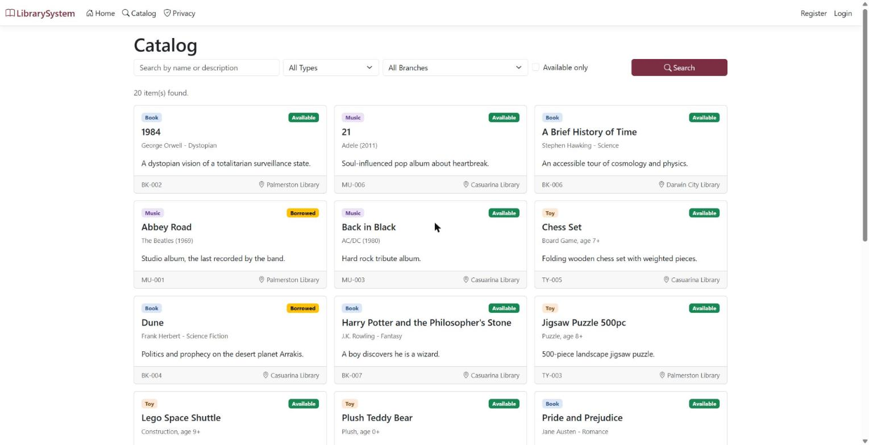
Figure 1 — the catalogue showing all available items
Step 3. Narrow the results using the boxes beside the search bar:
- Type — show only Books, only Music, or only Toys.
- Branch — show only items currently held at one particular library.
- Available only — hide anything currently on loan.
Step 4. Click Search.
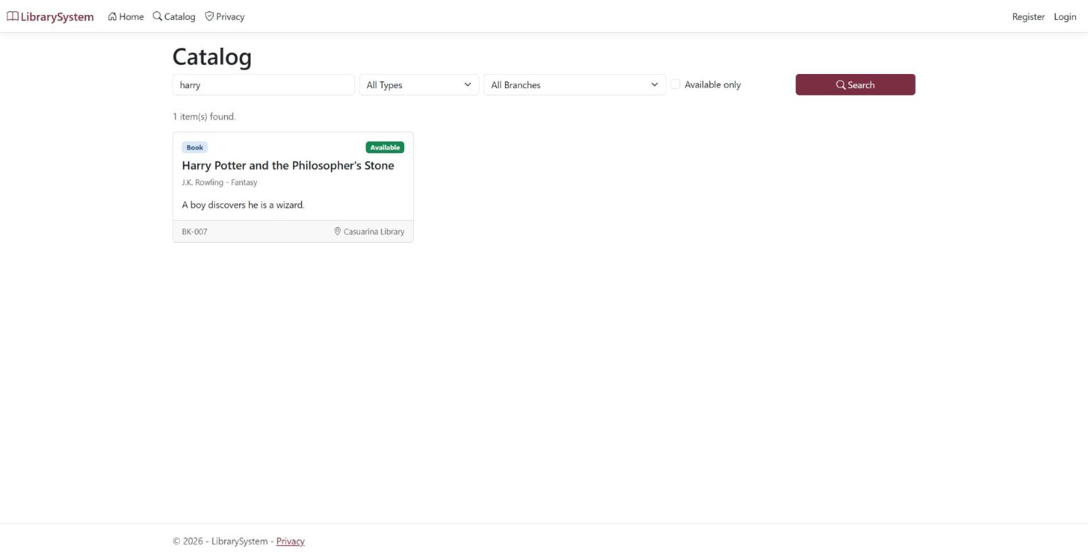
Figure 2 — a search for "harry" returning a single matching result
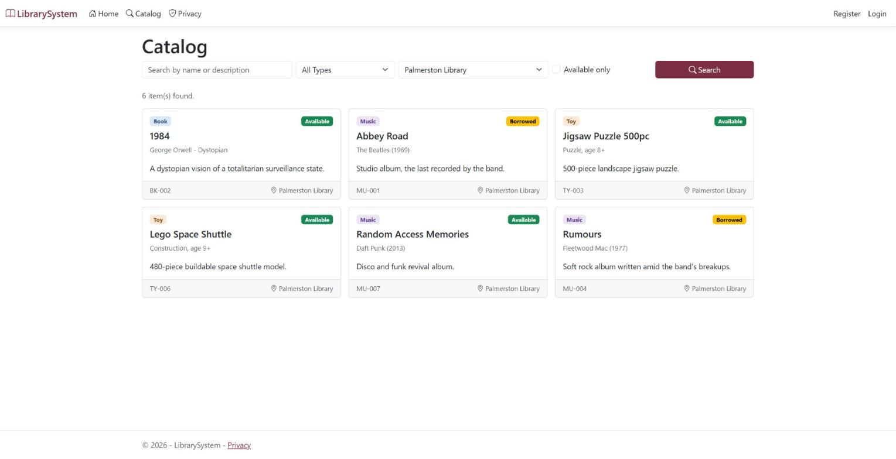
Figure 3 — the branch filter showing only items held at Palmerston Library

2.2 Reading your results
Each result appears as a card carrying everything you need at a glance:
- A coloured label showing the type — Book, Music or Toy.
- A second label showing availability — Available, Borrowed, Damaged or Destroyed.
- The title, the author, artist or toy type, and a short description.
- At the foot of the card: the item's library code and the branch currently holding it. Worth checking if you plan to visit in person, since items move between branches over time.
- If an item is unavailable and others are already waiting for it, a note such as "2 waiting". That is how many people would be ahead of you if you joined the queue now.
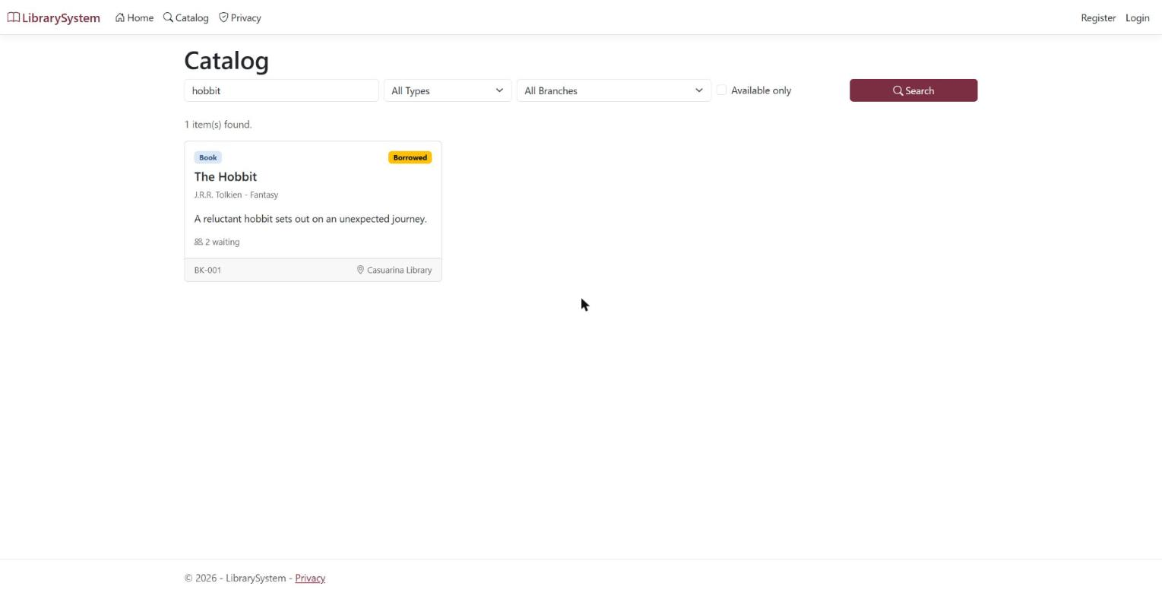
Figure 4 — an unavailable item showing its queue length
To join the queue for something on loan, visit the library and place a hold at the self-service kiosk, or ask a staff member at the front desk.

2.3 Searching at the library kiosk
Every branch has a touchscreen kiosk you can use without a password or an account. You only need your library card number when you want to borrow something, check your account, or join a queue.
Step 1. On the welcome screen, tap Search. The screen shows which branch you are at.
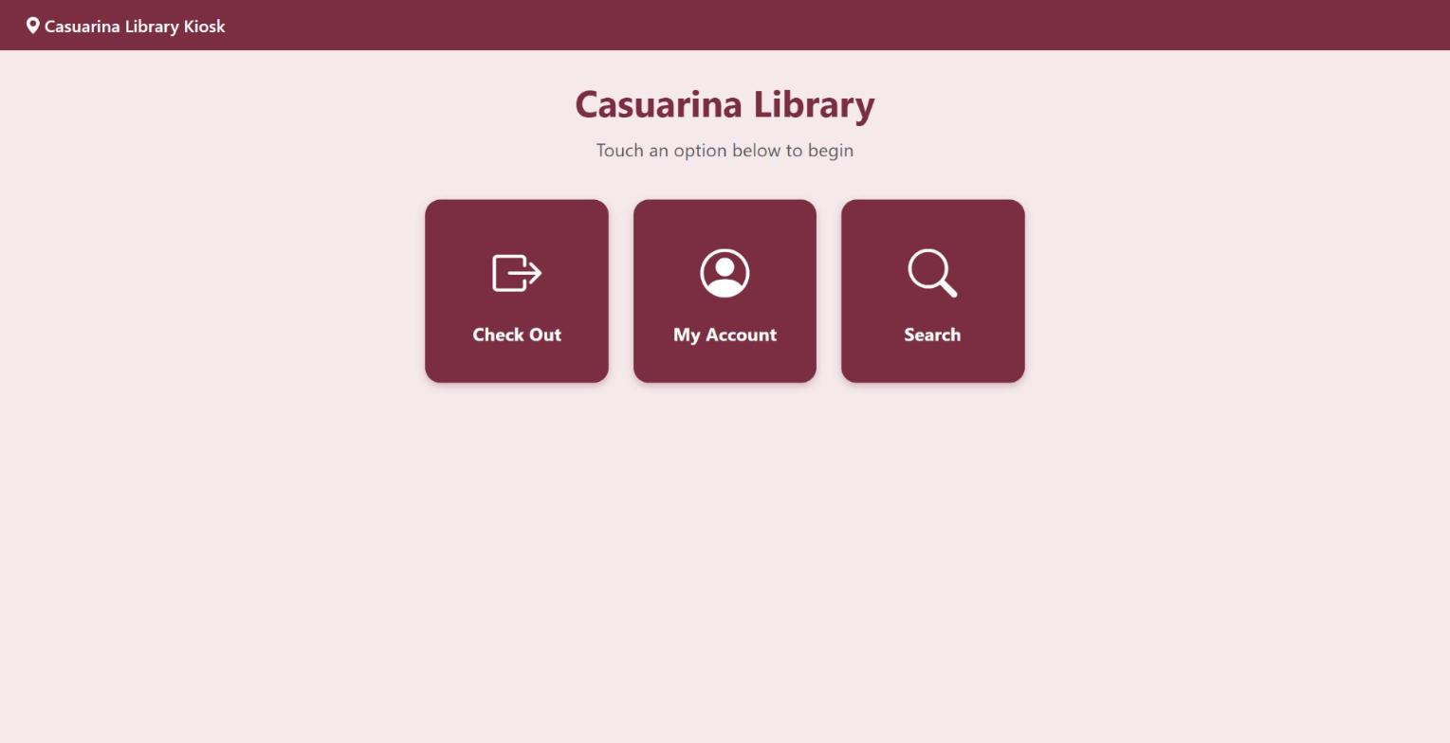
Figure 5 — the kiosk welcome screen
Step 2. Type using the on-screen keyboard. No physical keyboard is needed — tap the letters on the screen.
Step 3. Tap Search. Results show the same information as the website: title, availability and which branch holds the item.
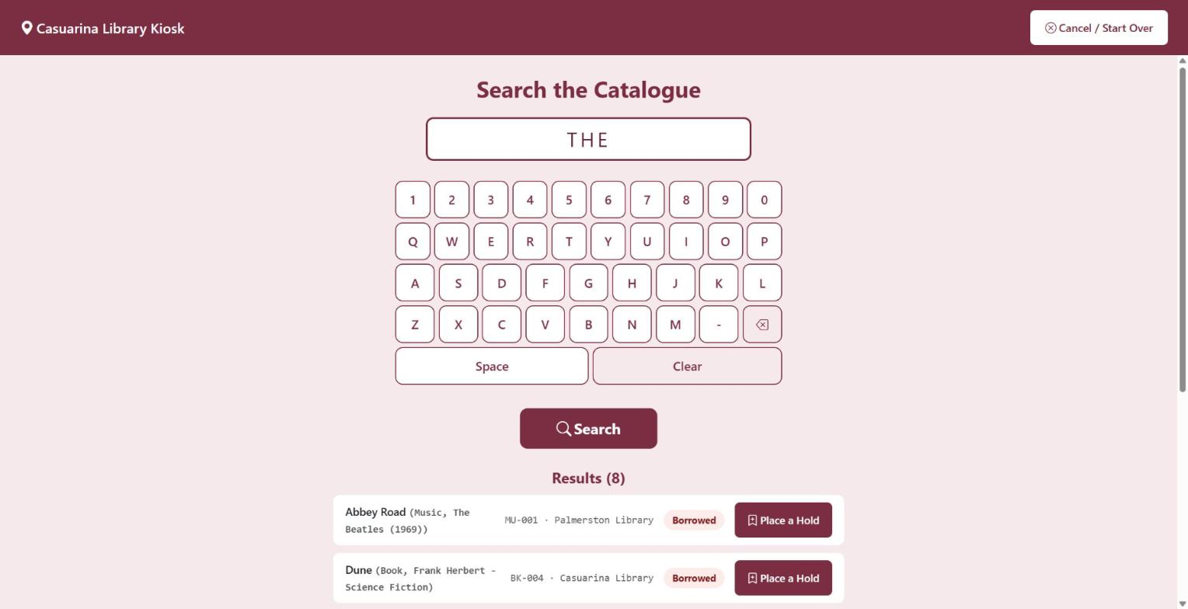
Figure 6 — kiosk search results, each with a Place a Hold action

2.4 Joining a queue at the kiosk
If a result you want is unavailable, a Place a Hold button appears beside it. Tapping it will ask for your library card number on the on-screen number pad, then confirm the hold and tell you your position in the queue.
You will be notified when the item becomes available, and it will be held for you for three days.
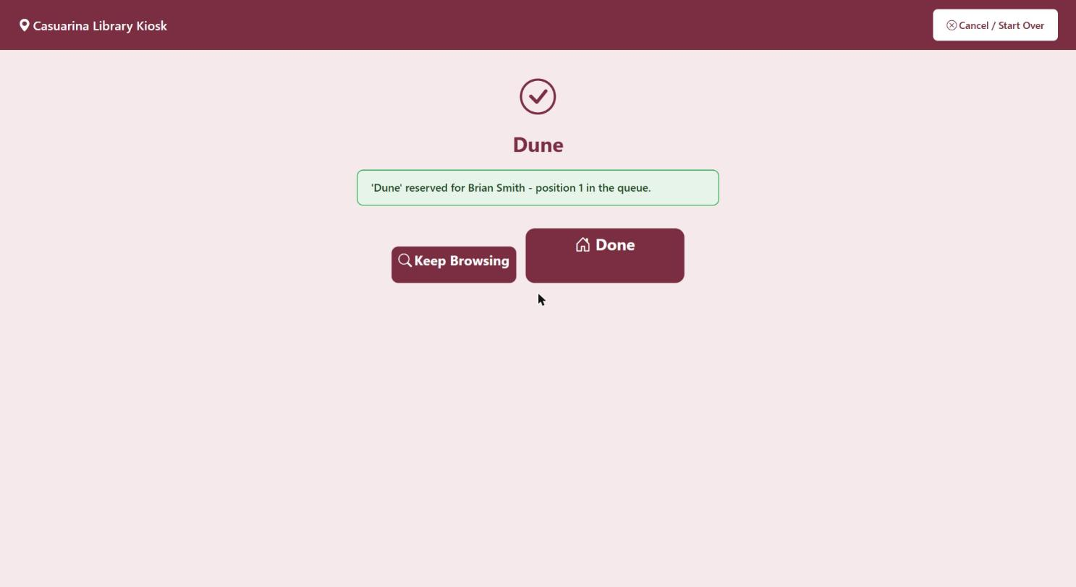
Figure 7 — confirmation after placing a hold, showing queue position

2.5 Things worth knowing about the kiosk
- Every screen has a Cancel / Start Over button in the top corner. Tap it at any time to return to the welcome screen.
- If the kiosk is left untouched for about a minute it returns to the welcome screen by itself, so your card number is never left visible to the next person.
- The kiosk can also check items out to you and show your current loans, fines and holds. Look for Check Out and My Account on the welcome screen.

3. Project plan

3.1 Working agreement
This project was delivered by a single member. Group enrolment closed on 28 September with no other students having joined, so what would normally be a team contract is recorded here as the working agreement I held myself to.
Commitments
- Deliver all seven Part B feature areas to a working, demonstrable standard before polishing any of them.
- Work in focused sessions rather than spread hours; every session ends with the application in a running state, committed and pushed.
- Never leave the repository in a state where a fresh clone would not build and run.
- Review every change before committing it, rather than accepting generated code unread.
Standards held to
- Business logic stays in the service layer; controllers orchestrate and nothing more.
- XML documentation comments on every new public service member.
- Existing conventions inherited from Assignment 2 are followed rather than replaced — naming, badge partials, view model shapes, the LoanResult success/failure pattern.
- Every new feature reuses the existing services where the rules already exist, so two channels can never enforce different rules for the same operation.
Source control discipline
- One commit per completed task, with a message naming what the task delivered.
- Commit only after the feature has been exercised in a running application, not merely compiled.
- Push on the same day as the commit, so the remote is never more than one session behind.
Handling slippage
The original plan allocated three days to documentation at the end. When the feature work ran longer than that allowed, I requested and was granted an extension rather than compressing the documentation — Part A carries two thirds of the available marks, so protecting it was the correct trade.

3.2 Requirements and acceptance criteria

Scope and assumptions
Seven Part B features extend the existing LibrarySystem codebase, delivered solo between 4 and 16 October. Breadth over depth: every feature reaches a working, demonstrable state before any of them is polished.
Baseline carried forward
- ASP.NET Core MVC on .NET 10, EF Core Code First, SQL Server LocalDB, solution stays .slnx
- Existing roles: Admin, Reception, Manager, anonymous Public
- Existing models: Item (TPH: Book/Music/Toy), Borrower, Loan; LoanService, StatisticsService, ILibraryClock
- Auto-migrate and auto-seed on startup stays intact — a fresh clone must still run with F5 alone
Design decisions
Decision | Choice | Why
How a running instance knows its branch | appsettings.json config key | Matches the brief's "choose a location where appropriate"; the only option that works for an unauthenticated kiosk
Item branch tracking | Home branch + current branch | Makes transfers meaningful and gives a free "items away from home" report
Returning at another branch | Allowed, auto-raises a transfer | Realistic trigger for the transfer queue; costs nothing extra to build
Reservation queue scope | System-wide, not per branch | Simpler queue logic; notification names the branch holding the copy
Notification delivery | Logged to a table with a dashboard view | Brief explicitly permits simulation; no external service or credentials needed
Patron identity | No patron logins — borrower ID or library card entered at the kiosk | Assignment 2 had no borrower accounts; adding them is large and earns no extra marks
Out of scope
Real email or SMS delivery, patron self-registration, payment gateway integration, deep refactoring of Assignment 2 code, and any architectural rework. The brief asks for breadth, not depth.

R1 — Multi-Branch Inventory Extension
Build this first: it changes the data model every other feature sits on.
New and changed models
Branch
├── Id, Code ("CAS"), Name
├── Address, Phone, OpeningHours
└── IsActive
Item + HomeBranchId, CurrentBranchId
Loan + BorrowedAtBranchId, ReturnedAtBranchId?
Transfer
├── Id, ItemId
├── FromBranchId, ToBranchId
├── RequestedDate, CompletedDate?
├── Status (Requested, InTransit, Completed, Cancelled)
└── RequestedByUserId, Reason
Requirements
- R1.1 — appsettings.json carries Library:BranchCode; a CurrentBranchAccessor resolves it to a Branch at request time and fails loudly on startup if the code matches no branch.
- R1.2 — The active branch name shows in the layout header on every authenticated page.
- R1.3 — Reception's borrow and return screens only list items whose CurrentBranchId is the active branch.
- R1.4 — Admin item create and edit require a home branch; current branch defaults to home on creation.
- R1.5 — Returning an item whose CurrentBranchId is not its HomeBranchId auto-creates a Transfer with status Requested.
- R1.6 — Reception has a Transfers screen: raise a transfer manually, mark InTransit, mark Completed (which sets CurrentBranchId to the destination), or cancel.
- R1.7 — Manager statistics gain a branch filter; the public catalogue shows which branch holds each item.
- R1.8 — Seed data creates three branches (Casuarina, Palmerston, Darwin City) with items spread across them, plus one item already away from home so the transfer queue is non-empty on first run.
Acceptance test
Change BranchCode from CAS to PAL, restart, and the header, reception item lists and transfer queue all reflect Palmerston without touching the database.

R2 — Digital Reservation & Waitlist Queue
Patrons place a hold on an item that is borrowed or damaged; the queue promotes the next person when it returns to available.
New model
Reservation
├── Id, ItemId, BorrowerId
├── PlacedDate
├── QueuePosition : int
├── Status (Waiting, Ready, Collected, Expired, Cancelled)
├── ReadyDate?, ExpiryDate?
└── NotifiedDate?
Requirements
- R2.1 — A hold can only be placed on an item whose status is Borrowed or Damaged; Available items are borrowed directly, not reserved.
- R2.2 — One active reservation per borrower per item; a duplicate attempt returns a clear message rather than a second row.
- R2.3 — QueuePosition is assigned on placement and recalculated when anyone leaves the queue.
- R2.4 — Reception can place a hold on a borrower's behalf and view the full queue for any item.
- R2.5 — When an item's status returns to Available, ReservationService promotes position 1 to Ready, sets a 3-day ExpiryDate, raises a notification (R3), and holds the item against general borrowing.
- R2.6 — A Ready reservation past its expiry is marked Expired and the next in queue is promoted.
- R2.7 — Borrowing an item that is Ready for someone else is blocked unless the borrower matches.
- R2.8 — The public catalogue shows the queue length on unavailable items; the kiosk (R7) can place a hold using a library card number.
Acceptance test
Two borrowers queue on one borrowed item. Return it: position 1 becomes Ready with a notification logged, position 2 moves to position 1, and a third borrower is refused at borrow time.

R3 — Automated Multi-Channel Notification System
Simulated email and SMS, written to a table and surfaced on a dashboard. No external service, no credentials, no network dependency.
New model
Notification
├── Id, BorrowerId
├── Channel (Email, Sms)
├── Type (Borrowed, DueSoon, Overdue, FineAccrued,
│ ReservationReady, TransferArrived)
├── Recipient (email address or phone, copied at send time)
├── Subject, Body
├── CreatedDate, SentDate
└── Status (Queued, Sent, Failed)
Requirements
- R3.1 — INotificationService.QueueAsync(...) is the single entry point; LoanService, ReservationService and the transfer flow call it rather than writing rows themselves.
- R3.2 — Channel is chosen per borrower: SMS when a phone number exists, otherwise email. Both are simulated.
- R3.3 — Bodies come from templates with token substitution (borrower name, item name, due date, amount), not strings concatenated inline.
- R3.4 — Triggers: item borrowed, item due within 3 days, item overdue, fine accrued, reservation ready, transfer arrived at destination.
- R3.5 — Due-soon and overdue notifications are produced by a sweep the Manager can run on demand from the dashboard, using ILibraryClock so the date logic stays testable.
- R3.6 — The sweep is idempotent: running it twice on the same day does not duplicate notifications for the same loan and type.
- R3.7 — A Notifications dashboard lists every notification with filters on channel, type, status and date, newest first, plus a detail view showing the rendered body.
- R3.8 — Each notification is also written to the console on send, so the simulation is visible while debugging.
Acceptance test
Run the sweep against seeded overdue loans: notifications appear on the dashboard with correct bodies, and a second run adds nothing.

R4 — Public API & Developer Endpoint
A read-only REST API over the catalogue, separate from the MVC controllers and returning JSON only.
Endpoints
Method | Route | Returns
GET | /api/v1/items | Paged catalogue; filters for search, type, branch, availableOnly
GET | /api/v1/items/{libraryCode} | One item with availability and holding branch
GET | /api/v1/categories | Item types with counts, plus book genres and toy types
GET | /api/v1/branches | Branches with address and opening hours
GET | /api/v1/status | Operating status: branch count, items available, API version, server time
Requirements
- R4.1 — Controllers inherit ControllerBase with [ApiController] and [Route("api/v1/[controller]")]; they live in a Controllers/Api folder, separate from the MVC controllers.
- R4.2 — Read-only: GET verbs only. Any POST, PUT or DELETE returns 405.
- R4.3 — Secured with an API key header (X-Api-Key) validated by middleware or an action filter against a key held in configuration. A missing or wrong key returns 401 with a JSON error body.
- R4.4 — Responses use dedicated DTOs, never EF entities, so borrower data and internal fields can never leak through navigation properties.
- R4.5 — /items paginates with page and pageSize (default 20, max 100) and returns total count alongside the results.
- R4.6 — Errors return consistent JSON: a status code, a message, and no stack traces.
- R4.7 — Swagger UI is enabled in development, and the README documents each endpoint with a sample request and response.
Acceptance test
Call each endpoint from the browser or Swagger with a valid key and get well-formed JSON; call /api/v1/items without the key and get 401.

R5 — Expanded Manager Analytics & Export
Three reports, each viewable on screen and downloadable as CSV and PDF.
Report | Contents
Borrowing statistics | Loans per period, most-borrowed items, active loans, overdue count, broken down by branch
Fine revenue audit | Fines accrued, paid and outstanding, per borrower and per period, with totals
Inventory health | Item counts by status and type per branch, items away from home branch, damaged and destroyed lists
Requirements
- R5.1 — IReportService builds each report as a typed view model; StatisticsService keeps the dashboard figures and is not duplicated.
- R5.2 — Every report takes a date range and an optional branch filter, and the chosen filters appear in the exported file.
- R5.3 — CSV is generated without a third-party dependency, with quoted fields and a header row that matches the on-screen columns.
- R5.4 — PDF uses QuestPDF (free for this use), with a header showing report name, branch, date range and generation timestamp, and page numbers in the footer.
- R5.5 — Downloads return correct content types and a filename carrying the report name and date, for example fine-revenue-2026-10-16.csv.
- R5.6 — An empty result set still produces a valid file with headers and a "no data" line, not an exception.
- R5.7 — Export buttons sit on each report page, and the Manager dashboard links to all three reports.
Acceptance test
Each of the three reports downloads as both CSV and PDF, opens cleanly in Excel and a PDF viewer, and the figures match what the screen shows for the same filters.

R6 — External Book/Media Data Importer
An Admin utility with two import paths: a CSV upload, and a lookup against a mock external metadata provider.
Requirements — CSV upload
- R6.1 — Admin uploads a CSV with columns Type, Name, Description, LibraryCode, HomeBranchCode plus the type-specific fields (Author, Genre / Artist, Year / ToyType, RecommendedAge).
- R6.2 — The file is parsed into a preview table before anything is saved; the Admin confirms the import explicitly.
- R6.3 — Each row is validated for required fields, a known item type, a known branch code, and a library code that is not already taken. Valid and invalid rows are shown separately with the reason per failure.
- R6.4 — The Admin can import only the valid rows, and a summary reports how many were created, skipped and rejected.
- R6.5 — The import runs in a single transaction so a mid-file failure leaves no partial data.
- R6.6 — A sample CSV is downloadable from the page and committed to the repository for the marker to use.
Requirements — mock external provider
- R6.7 — IMetadataProvider is an interface; MockMetadataProvider serves records from a bundled JSON file, so the feature works with no internet access on the marking VM.
- R6.8 — The Admin searches by title or ISBN, sees matching results, and imports one into the catalogue with a chosen home branch and library code.
- R6.9 — The interface is registered in DI so a real provider could replace the mock without touching the controller — call this out in the design rationale.
Acceptance test
Import the sample CSV, including two deliberately bad rows, and see them rejected with reasons while the good rows are created; separately, search the mock provider and import one record.

R7 — Public Self-Service Kiosk View
A stripped-back touch interface at /kiosk, built for a fixed in-library terminal rather than a phone. Anonymous, with its own layout.
Requirements
- R7.1 — KioskController is [AllowAnonymous] and uses _KioskLayout.cshtml: no site navigation, no login links, no footer.
- R7.2 — Large touch targets (minimum 48px), large type, high contrast, and an on-screen numeric keypad for entering codes so no physical keyboard is required.
- R7.3 — The kiosk operates as the branch named in Library:BranchCode, and shows that branch name on the idle screen.
- R7.4 — Check out: patron enters their library card number, then one or more library codes; each item is validated (exists, at this branch, available, not held for someone else) and borrowed through the existing LoanService.
- R7.5 — Account summary: card number entry shows current loans with due dates, overdue items flagged, outstanding fines, and active reservations.
- R7.6 — Place a hold: from a search result or an unavailable item, a patron can join the queue using their card number.
- R7.7 — Every screen has a visible Cancel or Start Over control, and the session resets to idle after 60 seconds of inactivity so the next patron starts clean.
- R7.8 — Errors are plain-language and actionable: "That item is already on loan" rather than a validation code.
Acceptance test
At 1024x768 with touch emulation, complete a checkout, view an account summary, and place a hold without using a keyboard; leave it idle and confirm it returns to the welcome screen.

3.3 Approach
Features were sequenced by dependency, not by the order the brief lists them, so that stopping at any point would still leave a coherent working application.
Sequencing
- Multi-branch first. It changes Item, Loan and reception scoping — the data model everything else sits on. Building it later would have meant retrofitting branch awareness into finished features.
- Notifications second. Reservations need somewhere to send a "your hold is ready" message, so the notification service had to exist before the reservation queue could be completed.
- Reservations third, completing the pair.
- API, exports, importer and kiosk last. Each is largely self-contained and reads from what the first three built, so any of them could have been cut under time pressure without leaving the system incoherent.
Toolchain
Tool | Used for
Visual Studio 2026 | Editing, debugging, running, source control
Claude Code (CLI) | Implementation against written specifications
Claude in Chrome | Browser-driven functional testing of completed features
GitHub + GitHub Projects | Repository and task board (public, read access for marking)
SQL Server Object Explorer | Verifying database state directly rather than inferring it from the UI
Source control workflow
A single master branch. The brief's "multi-branch locations" wording was clarified with the lecturer as referring to physical library branches, not git branches, so the same codebase serves every location with the branch chosen through Library:BranchCode in configuration.
Commits were made from Visual Studio under a GitHub noreply address, one commit per completed task. An early mistake — the first push used an unverified machine-generated identity, so commits did not link to my GitHub account — was corrected by resetting the repository before any history mattered.
Testing method
Each feature was verified in the running application before being committed, not merely compiled. Three levels were used:
- Direct database inspection for anything where the UI could mislead — confirming notification rows, reservation positions and seeded data actually existed as expected.
- Browser-driven functional testing for end-to-end flows, scripted as explicit step-by-step expectations so a divergence from the expected result was reported rather than rationalised.
- Deliberate edge-case construction where real data would not exercise the code: a CSV built with embedded commas, quotes and newlines to prove the escaping; an 80-row synthetic report to force PDF pagination; a shortened timeout to prove the kiosk's idle reset fires.
Documentation strategy
Technical documentation that describes the code — the README and installation manual — was generated against the codebase itself rather than from memory, so it describes what was built rather than what was planned. Judgement-based sections such as this one, the self-assessment and the design rationale were written directly.

3.4 Project management board
The project is managed on a public GitHub Projects board holding the task list in section 3.5: https://github.com/users/Binay216/projects/2/views/1. It opens without an account, so read access needs no credentials, and GitHub Projects is free, so there is no trial to expire.

3.5 Billable tasks and hours
Thirty-five tasks, every one allocated to Binay Siwakoti as sole member. Estimates were set on 4 October before any implementation began; implementation actuals are reconstructed from the repository's commit history (see the note under Variance). Documentation and testing actuals are self-reported, as most of that work was written outside the repository.
ID | Task | Stream | Est. | Actual | Date
T01 | Set up PM board, import task list, grant marker read access | Planning | 1.0 | 2.0 | 4 Oct
T02 | Branch and Transfer models, Item and Loan changes, migration | Multi-branch | 3.0 | 1.0 | 5 Oct
T03 | Branch config accessor, startup validation, layout header | Multi-branch | 2.0 | 0.8 | 5 Oct
T04 | Reception branch scoping on borrow and return screens | Multi-branch | 2.0 | 0.7 | 5 Oct
T05 | Admin item create/edit with home branch | Multi-branch | 1.5 | 0.5 | 7 Oct
T06 | Transfer queue screens and status workflow | Multi-branch | 3.5 | 1.0 | 7 Oct
T07 | Branch filter on manager stats, branch on public catalogue | Multi-branch | 1.5 | 0.7 | 7 Oct
T08 | Multi-branch seed data across three branches | Multi-branch | 1.5 | 0.5 | 5 Oct
T09 | Notification model, service, templates, migration | Notifications | 3.0 | 0.8 | 7 Oct
T10 | Notification triggers wired into loan and transfer flows | Notifications | 2.0 | 0.5 | 7 Oct
T11 | Due-soon and overdue sweep, idempotency guard | Notifications | 2.5 | 0.6 | 7 Oct
T12 | Notifications dashboard with filters and detail view | Notifications | 2.5 | 0.6 | 7 Oct
T13 | Reservation model, service, queue logic, migration | Reservations | 3.5 | 0.6 | 7 Oct
T14 | Reservation promotion on return, expiry handling | Reservations | 3.0 | 1.2 | 8 Oct
T15 | Reception reservation screens, borrow-time hold check | Reservations | 2.5 | 1.0 | 8 Oct
T16 | Queue length on public catalogue | Reservations | 1.0 | 0.3 | 8 Oct
T17 | API DTOs and read-only controllers | API | 3.0 | 1.5 | 8 Oct
T18 | API key authentication filter and error handling | API | 2.0 | 0.4 | 14 Oct
T19 | Pagination, filtering, Swagger, endpoint docs | API | 2.0 | 0.4 | 14 Oct
T20 | ReportService and three report view models | Exports | 3.0 | 0.3 | 14 Oct
T21 | CSV export generation and download endpoints | Exports | 2.0 | 0.3 | 14 Oct
T22 | QuestPDF integration and PDF report layouts | Exports | 3.0 | 0.3 | 14 Oct
T23 | Report pages, export buttons, empty-state handling | Exports | 2.0 | 0.3 | 14 Oct
T24 | CSV parser, validation, preview and confirm flow | Importer | 3.5 | 0.3 | 14 Oct
T25 | Mock metadata provider, search and import | Importer | 2.5 | 0.2 | 14 Oct
T26 | Kiosk layout, idle screen, keypad, timeout | Kiosk | 3.0 | 0.2 | 14 Oct
T27 | Kiosk checkout, account summary, hold placement | Kiosk | 3.5 | 0.4 | 14 Oct
T28 | Installation and running instructions, VM-tested | Documentation | 2.5 | 1.3 | 14–15 Oct
T29 | User guide for patron search capabilities | Documentation | 2.0 | 1.2 | 14 Oct
T30 | Integration diagrams and user journey maps | Documentation | 3.0 | 1.5 | 14 Oct
T31 | Project plan, approach, working agreement, progress log | Documentation | 2.5 | 1.3 | 14 Oct
T32 | Strengths and weaknesses self-assessment | Documentation | 1.5 | 1.0 | 14 Oct
T33 | README update: new modules, seeding, testing integrations | Documentation | 1.5 | 1.0 | 14 Oct
T34 | Fresh-clone test, VM install test, full regression pass | Testing | 3.0 | 1.5 | 14–15 Oct
T35 | Portfolio assembly and submission | Submission | 1.5 | 1.0 | in progress
Totals by stream
Stream | Estimated | Actual
Planning | 1.0 | 2.0
Multi-branch | 15.0 | 5.2
Notifications | 10.0 | 2.5
Reservations | 10.0 | 3.1
API | 7.0 | 2.3
Exports | 10.0 | 1.2
Importer | 6.0 | 0.5
Kiosk | 6.5 | 0.6
Documentation, testing, submission | 17.5 | 9.8
Total (implementation only) | 65.5 | 17.4
Total (all work) | 83.0 | 27.2

3.6 Variance commentary
Implementation came in at roughly 17 hours against 65.5 estimated — about 27% of the estimate. The gap is large enough that it needs explaining rather than celebrating.
How the actuals were derived. Hours were not logged live. They are reconstructed from the public commit history at github.com/Binay216/LibrarySystem/commits/master, by taking each working day's first and last commit as the session boundary and distributing that session across the tasks committed within it. The figures are therefore accurate to the session and approximate at the individual task level. This is a genuine process weakness and is recorded as such in the self-assessment rather than smoothed over — a marker can verify the session boundaries against the repository, but not the per-task split.
Why the estimates were four times high. The estimates were built on 4 October assuming hand-written code: typing models, controllers, views and migrations directly. The work was actually done by specifying each task in writing and having an AI coding assistant implement it, then reviewing and testing the result. That changes the shape of the work rather than merely speeding it up:
- Scaffolding collapsed. Models, DbContext configuration, migrations, controllers and Razor views are the bulk of an estimate like this and the part that compresses most. The export stream — three reports, CSV generation, PDF generation and three pages — was estimated at 10 hours and took roughly 1.2.
- Review and testing did not compress. Reading the generated code, running the application, constructing edge cases and verifying database state took the same time they always would, and became the dominant cost per task rather than a minor one.
- Debugging did not compress either. Several hours across the project went to defects, none of which were faster to find for having been written quickly.
Where time actually went. The variance is not uniform. Multi-branch, the first stream, ran at about 35% of estimate; the final day's work ran at under 10%. That curve is the learning effect of getting better at writing specifications: the early prompts were vaguer, produced work that needed correcting, and cost round trips. Three defects account for a disproportionate share of the total:
Defect | Cost
Seed guard preventing updated seed data from appearing, encountered three separate times before the pattern was recognised | ~1.5 h
Notification filter parameters never binding, because the controller parameter names did not match the view model property names — a silent failure with no error | ~0.5 h
Reservation queue positions not re-derived on every exit path, producing a queue with no position 1 | ~0.7 h
The honest conclusion. The estimates were not carelessly made; they were made for a different method of working than the one used. If I were estimating this project again with the same toolchain, I would budget roughly a quarter of the implementation time and substantially more for review, testing and documentation — which is where the remaining 17.5 estimated hours now sit, and where I expect the variance to be far smaller, because writing a user guide and testing on a virtual machine do not compress the way scaffolding does.
How that prediction held. Documentation, testing and submission came in at 9.8 hours against 17.5 estimated, about 56% of the estimate against 27% for implementation, so the gap narrowed as expected. These hours are self-reported per task rather than reconstructed from commits, because the diagrams, project plan and design rationale were written outside the repository and left no commit trail. Across the whole project that makes 27.2 hours against 83.0 estimated, with portfolio assembly still in progress at the time of writing.

3.7 Progress log
With no team there were no meetings to minute. This log serves the same purpose: a dated record of what was decided, what was completed, what blocked progress, and what came next. Dates are corroborated by the commit history.
16 September — Repository setup
Decided: push the Assignment 2 codebase to GitHub ahead of group formation, kept private initially. Confirmed with the lecturer that .slnx is acceptable, so no conversion to .sln was needed.
Completed: repository created and pushed; fresh-clone test passed.
Blocked: the first push committed under a machine-generated identity (Binay@BINAY) that GitHub could not verify, so commits did not link to my account. Resolved by setting a GitHub noreply address in git config, deleting the repository and local .git, and pushing again cleanly before any history mattered.
4 October — Planning
Decided: complete the project solo, group enrolment having closed on 28 September with no other members. Confirmed with the lecturer that "multi-branch locations" refers to physical library branches, not git branches, so a single codebase with configuration-driven branch selection is the correct reading.
Decided: four design positions set before any code — branch via config rather than per-staff account; items carry both a home and a current branch; returns permitted at any branch, auto-raising a transfer; reservations system-wide rather than per-branch.
Completed: requirements document covering all seven features as testable criteria; 35-task breakdown with estimates; GitHub Projects board created, populated and made public for marking.
Next: multi-branch domain model.
5 October — Multi-branch foundation
Completed: Branch and Transfer entities, branch fields on Item and Loan, migration, three seeded branches, configuration accessor with startup validation, reception scoping on borrow and return.
Blocked: the migration could not be applied to the existing database — non-nullable branch columns on 20 existing items would have failed the foreign key constraint. Resolved by rebuilding the database rather than writing a backfill, since seeded data made a rebuild cheap.
7 October — Transfers and notifications
Decided: an item's current branch becomes read-only on the admin edit form, so physical location changes can only happen through an auditable transfer. The original specification allowed both to be edited directly; this was tightened on review.
Decided: Transfer carries no borrower reference, so a "transfer arrived" notification was deliberately not wired — forcing a staff user id into a borrower field would have been dishonest data.
Completed: transfer queue with source-marks-dispatch and destination-marks-receipt, branch filtering on manager dashboards, notification model and service with per-channel templates, triggers on borrow and fine, due-date sweep with per-day idempotency, notifications dashboard.
Blocked: notification dashboard filters silently did nothing and reset on every submission. Root cause was a controller parameter name that did not match the view model property the form posted — a failure with no error message of any kind. Recorded as a lesson.
8 October — Reservations and API
Decided: queue positions are re-derived from placement order on every change rather than shifted incrementally. A shift is only correct if the existing numbering is already correct, so it propagates any drift; re-derivation is self-correcting.
Completed: reservation promotion on return, hold enforcement at borrow time, expiry handling, reception reservation screens, queue length on the public catalogue, first cut of the read-only API with DTOs.
Blocked: browser testing of the reservation flow produced the wrong result twice before the cause was identified — both times the seed guard had prevented updated seed data from reaching an existing database, so the feature was being tested against data that did not contain what the test assumed. Third occurrence of the same trap.
14 October — Remaining features
Decided: the mock metadata provider reads from an embedded JSON resource rather than calling a live external API, so the feature is demonstrable on a marking machine with no internet access.
Completed: API key authentication, Swagger with header support, three report services with CSV and PDF export, report pages with date and branch filters, CSV importer with preview and validation, mock metadata provider, kiosk shell and kiosk transactions. All seven Part B features complete.
Blocked: an exception filter implemented as a controller interface never fired — ASP.NET Core only auto-wires action and result filters that way, not exception filters, so unhandled API errors would have returned a full stack trace. Found by deliberately throwing from a temporary endpoint rather than by reading the code.
Next: documentation and portfolio, with an extension granted to 19 October.
14–15 October — Documentation and testing
Completed: README rewritten; installation guide and patron user guide written; a due-soon loan added to the seed data so the notification sweep has something to send.
Blocked: a fresh-clone test on 14 October found three defects. Timestamps ran an hour ahead because the clock used Adelaide time, which observes daylight saving; switched to Darwin. The notifications table clipped its Details button on narrow screens. The sweep summary said notifications were queued when they had been sent. All three fixed the same evening.
Completed: clean install test on a Windows Server 2019 virtual machine with Visual Studio 2026 Community, which surfaced three more issues. A high-severity vulnerability warning on System.Security.Cryptography.Pkcs 9.0.11, pulled in through the SQL Server provider, was fixed by pinning the patched 10.0.13. Windows Defender quarantining QuestPDF's native graphics binary, and Internet Explorer failing to render the interface, were documented in the installation guide.
Decided: fix the vulnerable package with a direct pinned reference rather than suppressing the warning.
Completed: 18 screenshots captured against a running instance as evidence for the portfolio; portfolio assembly started.
Next: assemble the portfolio and submit by 19 October.

3.8 Strengths and weaknesses
With no team to assess, this is a self-assessment. I have tried to make the weaknesses specific enough to be useful rather than safe.

Strengths
I verify rather than assume. Almost every task in this project ended with me running the application and checking the result before committing, and several times that caught something the code review had not. The reservation hold refusal appeared broken in testing twice before I established that the seed data, not the logic, was at fault. The notification dashboard filters looked correct in the markup and did nothing in practice. Neither would have been found by reading code.
I work in small, verifiable increments. Twenty-five commits across five working days, each one a single completed task with the application in a running state. When a defect appeared I always had a known-good point to reason back from, and at no stage was the repository in a state where a fresh clone would not build.
I used my toolchain deliberately rather than as a single hammer. Planning and specification in one place, implementation in another, browser-driven verification in a third, and direct database inspection when the interface could not be trusted to tell the truth. Separating those was what made the AI-assisted parts reviewable instead of a black box.
I accept correction. More than one design decision in this project was changed after I was challenged on it — making the current branch read-only on the item edit form, and reconsidering how I would present pre-group work in the task allocations. I would rather be corrected before submission than defend a weak position.

Weaknesses
I struggled to interpret the brief. Several requirements were ambiguous to me on first reading, most significantly the instruction that each location should "choose a location branch" — I could not tell whether that meant a git branch per library site or a single codebase with configurable branch selection, and the two lead to completely different repository structures. I resolved it by asking the lecturer, which was the right move, but I had already lost time weighing an approach that turned out to be wrong. Mitigation: on a longer project I would front-load a clarification pass — read the brief once purely to list every ambiguity, and resolve them all in one message before any planning.
Architectural decisions were the hardest part of the project for me. Choosing between configuration-driven and per-staff branch identity, deciding whether an item needed both a home and a current branch or just one, working out where reservation expiry logic should live — I found these genuinely difficult and often could not tell whether a design was sound until it had been built and I could see what it made easy or hard. I leaned heavily on advice for these calls rather than arriving at them independently. Mitigation: the pattern I noticed is that the decisions I found hardest were the ones where I could not picture the consequence. Writing down two concrete scenarios per option before choosing — what happens to a staff member who moves branch, what happens when an item is returned to the wrong site — made the right answer obvious in hindsight. I would make that an explicit step rather than an occasional one.
I did not track my time. The hours in this plan were reconstructed from commit timestamps after the fact, because I never logged a session as I worked. Given that time tracking is itself an assessed artefact of this project, that is a poor outcome, and it also cost me the per-task accuracy I would have had for free. Mitigation: a timestamp at the start and end of each session, written in the same place as the task board, would have taken seconds per day.
I repeated the same mistake three times. Entity Framework seed data only runs against an empty database, so three separate times I changed seeded data, tested against a database that still held the old data, and drew a wrong conclusion about whether a feature worked. The first occurrence is forgivable; the third means I was not recording what I learned. Mitigation: I now treat "did the data actually change?" as the first question when a test result surprises me, and it is documented in the README so the marker does not hit the same wall.
I deferred documentation despite knowing its weight. Part A carries 40 of the 60 available marks and I left it until every feature was finished, which is the opposite of what the mark allocation justifies. I was aware of this at the time and chose to keep building anyway. It required an extension that would otherwise not have been necessary. Mitigation: on a weighted assessment, allocate effort to the weighting rather than to what is most enjoyable to work on — and write documentation alongside the feature it describes, while the decisions are fresh, rather than reconstructing the reasoning weeks later.

What I would do differently
If I started this project again: resolve every ambiguity in the brief in one pass before planning; write down the concrete consequences of each design option rather than choosing on instinct; log hours as I go; and write each feature's documentation in the same session as the feature itself.

4. Integration diagrams

4.1 System architecture
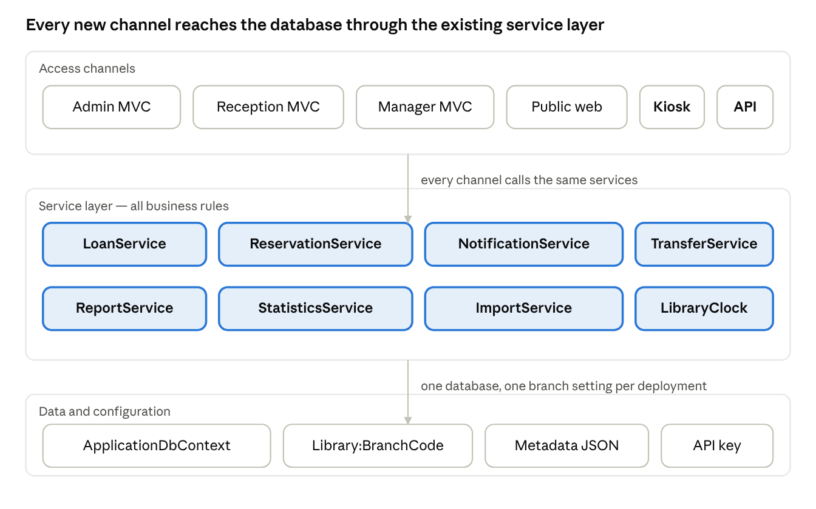
system architecture · 6 channels, 8 services, one database
The two new access channels — the kiosk and the public API — do not reach the database directly. Both call the same service layer the existing MVC controllers use, so a rule enforced for reception is automatically enforced at the kiosk. The kiosk borrows through LoanService.BorrowAsync, which is where the branch check, the availability check and the reservation hold check already live.
The branch a deployment operates as comes from configuration, not from the user. That single setting determines what reception can borrow, which transfers appear in the queue, and which branch the kiosk belongs to.

4.2 Multi-branch data model
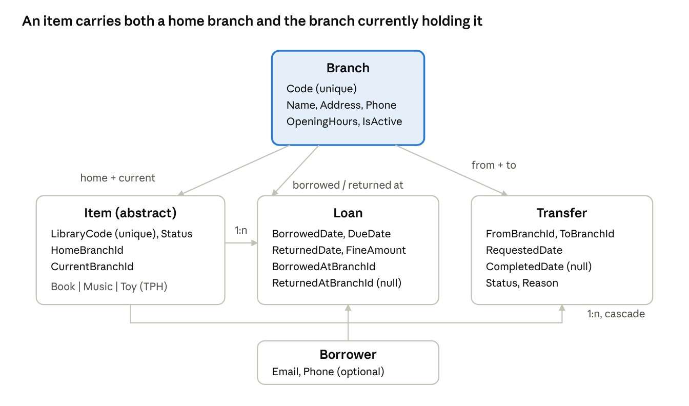
multi-branch data model · 5 entities, 6 branch references
Six foreign keys point at Branch, which is why they are configured explicitly rather than left to Entity Framework's conventions — two references from one entity to another cannot be inferred.
The decision worth defending is that Item carries both HomeBranchId and CurrentBranchId rather than one location field. With a single field a transfer would be nothing more than an update, and the system could not answer "which items are away from where they belong". With both, a transfer has a meaning, the inventory health report has a real question to answer, and returning an item at the wrong site has a visible consequence.
All branch foreign keys use Restrict on delete, so a branch cannot be removed out from under the items it holds. The transfer-to-item relationship is the exception and uses Cascade: an item's transfer history has no meaning once the item is gone, and Restrict there would have blocked the existing admin delete.

4.3 Reservation and notification flow
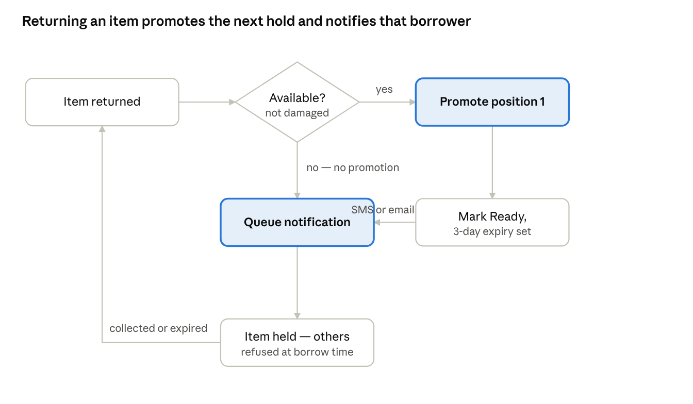
reservation promotion flow · 6 steps, 1 decision, 1 loop
This is the integration point between two modules that were built separately. LoanService.ReturnAsync does not know how reservations work; it calls ReservationService.PromoteNextAsync, which does not know how notifications are rendered; that calls NotificationService.QueueAsync.
Every link in the chain is wrapped so a failure cannot break the operation that triggered it. If the notification fails to queue, the promotion still stands. If the promotion fails, the return still succeeds. A patron never has an item refused at the desk because a downstream message could not be composed.
Promotion only happens when the item comes back Available. An item returned damaged or destroyed is not collectable, so notifying the next person in the queue would be worse than saying nothing.

5. User journey maps

5.1 Patron at the kiosk
Who: a library patron standing at a fixed terminal inside a branch, with no account and no staff member present.
Stage | What the patron does | What the system does | Where it can go wrong
Arrive | Sees the idle screen naming this branch and three large tiles | Shows Check Out, My Account, Search; no nav, no login | A previous patron's session left on screen — prevented by the 60-second idle reset
Identify | Taps Check Out, enters a card number on the on-screen keypad | Looks up an active borrower by that number | Unknown or inactive card — "We couldn't find an account for that card number"
Scan an item | Enters a library code | Validates through the same service reception uses: exists, at this branch, available, not on hold | Item on loan — offered "Place a Hold Instead" rather than a dead end
Repeat | Enters further codes | Each borrowed item joins a running list with its due date | None — the list persists across entries within the session
Check account | Taps My Account, enters card number | Shows current loans, overdue flagged, outstanding fines, active holds with queue position | None
Finish | Taps Done, or walks away | Session cleared, card number discarded, back to idle | Walking away without finishing — covered by the idle timer
Design response. Every error message was rewritten for a patron rather than a staff member. The checkout failure for an already-borrowed item offers the hold instead of merely refusing, because that is what the patron standing there actually wants.
Known weakness. The card number is the borrower's primary key, so it is sequential and guessable. Acceptable for a demonstration, wrong for a real deployment, which would need a separate non-sequential card number or a PIN.

5.2 Reception coordinating a transfer
Who: reception staff at one branch, moving an item to another. Two people at two sites share this journey, each seeing only their own half.
Stage | Who acts | What happens | Where it can go wrong
Trigger | Either branch, or the system | Staff raise a transfer manually, or a return at a branch that is not the item's home auto-raises one with reason "Returning to home branch" | An item already has an active transfer — refused, one at a time
Appears | Both branches | Shows under Outgoing at the source and Incoming at the destination | None
Dispatch | Source branch only | Marks the transfer In Transit when the item physically leaves | The destination cannot mark dispatch — the button is not shown to them
Receive | Destination branch only | Marks Complete; the item's current branch updates and the date is stamped | The source cannot mark receipt — only the branch holding the item can confirm it arrived
Visible outcome | Any branch | Item disappears from the source's reception lists and appears in the destination's | None
Abandon | Either branch | Cancel from Requested or In Transit; the item stays where it is | None
Design response. Splitting dispatch and receipt between the two branches means neither can complete a transfer alone. That mirrors the physical reality — the branch that still has the item cannot know it arrived somewhere else — and it leaves an audit trail with two distinct actors.
Only items with status Available can be transferred. An item on loan cannot be moved, because it is not physically at the branch to move.

5.3 Manager producing a report
Who: a library manager who needs figures for a period, either to read now or to send to someone who cannot log in.
Stage | What the manager does | What the system does | Where it can go wrong
Start | Opens the dashboard | Shows live figures for all branches, plus links to three reports and the notification sweep | None
Choose a report | Picks Borrowing, Fine Revenue or Inventory Health | Opens that report defaulted to the last month, all branches | None
Narrow | Sets a date range and a branch | Recalculates on screen against those filters | A period with no activity — zeroed totals and "No data for this period", not an error
Read | Reviews the figures | Summary band, then the supporting tables | None
Export | Clicks CSV or PDF | The download carries the filters currently on screen, and the file states them in its header | The export silently using different filters to the page — prevented by building the links from the applied filter values
Share | Opens or forwards the file | CSV opens in Excel with correct escaping and encoding; PDF repeats its headers across pages and numbers them | None
Design response. The filter carrying through to the export is the detail that quietly breaks in systems like this, and it was the specific thing tested: a branch filter applied on screen, the same parameters downloaded, and the file compared line for line against the page.
Every exported file states its own report name, date range and branch at the top, so a file that has left the system can still say what it is.

5.4 Developer consuming the API
Who: an external developer building something against the catalogue — a community app, a campus directory, a display board. They have no account and never see the web interface.
Stage | What the developer does | What the system does | Where it can go wrong
Discover | Opens /swagger in development | Lists all five endpoints with descriptions, parameters and possible responses | None
Authenticate | Clicks Authorize, pastes the API key | Every subsequent call carries X-Api-Key | No key — 401 with a JSON body, not an HTML login page
Explore | Calls /api/v1/status | Returns branch count, items available, API version, server time | None
Query | Calls /api/v1/items with search, type, branch and availability filters | Returns a page of results with total count, page and page size | A bad parameter value — 400 naming every invalid field, not just the first
Page | Requests page 2 | Ordered by name then library code, so no item repeats or disappears between pages | Unstable paging — prevented by the second sort key
Look up one item | Calls /api/v1/items/{libraryCode} | Returns the item with its type-specific fields and holding branch | Unknown code — 404 in the same JSON error shape
Integrate | Reads the README | Every endpoint documented with a sample request and a real captured response | None
Design response. The API returns hand-built DTOs, never Entity Framework entities. That is not a style preference: an entity carries navigation properties, so serialising one could expose borrower names, email addresses and loan history through a public endpoint. With DTOs there is no path for that data to travel, by accident or otherwise.
The identifier exposed is the library code, not the numeric primary key, so the API does not leak how many items exist or the order they were added.

6. Design rationale

6.1 How a deployment knows which branch it is
Decision: a configuration setting, not a property of the logged-in user.
The brief states that each location should follow the same installation instructions and "choose a location branch where appropriate". That left two readings, and the wrong one would have shaped the whole repository, so it was clarified with the lecturer before any code: the branches are physical library locations, not git branches. One codebase serves every site.
That still left the question of how a running instance knows which site it is. Two options were considered:
Option | How it works | Why not
Per-staff account | Each staff user is assigned a branch; the app uses the logged-in user's branch | Cannot work for the kiosk, where nobody logs in, or for the public catalogue
Configuration setting | Library:BranchCode in appsettings.json; the whole deployment is that branch | Chosen
Configuration won for two reasons. It is the only option that answers the question for an unauthenticated kiosk terminal, and it maps directly onto the brief's installation requirement: the same instructions everywhere, with one line changed per site.
The cost is that a staff member who moves between branches cannot carry their identity with them — they are whichever branch the machine in front of them is configured as. For a library front desk that is arguably correct behaviour rather than a limitation, since the items they can physically handle are the ones in that building.
The setting is validated at startup. If BranchCode does not match a seeded branch, the application refuses to start and names the valid codes, rather than running in a half-configured state and failing somewhere less obvious.

6.2 Why an item has two branches, not one
Decision: Item carries both HomeBranchId and CurrentBranchId.
The obvious model is a single BranchId saying where the item is. It is simpler, it is one column, and it answers the only question the brief asks directly — which branch holds this item.
It was rejected because it makes a transfer meaningless. With one field, moving an item between branches is an UPDATE and nothing more: no before, no after, nothing the system can reason about. The brief asks for staff to "coordinate inter-branch item transfers", and coordination implies a thing with a state, not a value being overwritten.
With two fields, several things fall out for free:
- A transfer has a direction and a meaning: an item is away from where it belongs.
- The inventory health report can answer "which items are not at their home branch", which is a real question a library manager would ask and which the single-field model cannot express.
- Returning an item at the wrong site has a visible consequence rather than silently relocating it. The system auto-raises a transfer back to its home branch.
The cost is one extra column, two more foreign keys, and remembering which field to filter on in each query. Items are filtered on CurrentBranchId because that is where they physically are; loans are filtered on BorrowedAtBranchId because that is where the transaction happened.
A related decision made on review. The admin item edit form originally allowed both branches to be changed directly. That was tightened: CurrentBranch is read-only on the edit form, with a note pointing at Transfers. An item's physical location should change through exactly one auditable path, not two, and leaving a back door open would have made the transfer history unreliable.

6.3 Why queue positions are re-derived, not shifted
Decision: every change to a reservation queue renumbers the whole queue from placement order.
The intuitive approach to someone leaving a queue is to decrement everyone behind them. It is cheap and it looks obviously correct.
It is only correct if the existing numbering is already correct. A shift reads the stored positions as input, so any drift — from a bug elsewhere, a manual data fix, or a code path written later that forgets to renumber — gets carried forward and compounded rather than repaired.
The approach taken instead: mark the reservation as leaving, then re-fetch every still-active reservation for that item, order them by PlacedDate with Id as a tiebreaker, and number them 1 to N from scratch. It never reads the old positions, only an independent fact about when each hold was placed. A queue is a handful of rows, so the cost is negligible.
This was proven necessary during testing, not just argued for. The first implementation only renumbered on cancel. A reservation that left the queue by being collected — the borrower picking the item up — did not trigger a renumber, so the queue was left with a position 2 and no position 1. Worse, placement calculated the new position as activeCount + 1, which then handed out a second position 2 and silently reproduced the gap.
The fix was to extract one private RenumberQueueAsync method and call it from every path that changes who is active on an item: place, cancel, collect, expire and promote. Promotion does not actually remove anyone from the active set, so calling it there is a no-op — it is called anyway, because the bug being defended against is precisely "every path except the one we forgot".
One subtlety worth recording. The renumbering query excludes the departing reservation by Id, not by filtering on its status. The status change exists in memory but has not been saved, and Entity Framework translates the query to SQL against the persisted database state — so a status filter would have pulled the just-cancelled row straight back in as active and corrupted the renumbering.

6.4 Why the API never returns an entity
Decision: every API response is a hand-built DTO, and the public identifier is the library code, not the primary key.
Returning Entity Framework entities directly is the fastest way to build an API and it is the reason public endpoints leak private data. An entity carries navigation properties: Item has Loans, each Loan has a Borrower, and a Borrower has a name, an email address and a phone number. Whether any of that serialises depends on what happened to be loaded, which is a fragile thing to rest a privacy guarantee on.
With purpose-built DTOs there is no path for that data to travel at all. It is not a question of configuring the serialiser correctly; the object simply does not contain it.
What is exposed
LibraryCode, Name, Description, Type, Status, the holding branch name, and the reservation queue count. The single-item endpoint additionally returns the structured type-specific fields — author and genre, artist and year, toy type and recommended age — since a lookup of one item is exactly where structured data earns its place over a flattened summary string.
What is deliberately withheld
Withheld | Why
The numeric Id | A sequential key leaks how many items exist and the order they were added
HomeBranchId / away-from-home status | Internal logistics, not a public concern
Anything from Loans or Borrower | The whole point of the DTO boundary
IsActive on branches | Implied — only active branches are ever returned
Any borrower or loan figure in /status | Branch count, available items, version and server time only
Related. The API is read-only by construction, not by policy: there are no POST, PUT or DELETE actions to disable. It requires an X-Api-Key header validated by a filter applied to the shared controller base, and the filter fails closed — a blank configured key denies all requests rather than letting a blank header match it.

6.5 Why nothing reaches the network
Two features describe external systems, and neither actually calls one. That is deliberate in both cases, for the same reason: a feature that depends on the internet is a feature that cannot be demonstrated on a marking machine with no connection, a blocked outbound port, or an expired API key.
Notifications are simulated to a table. The brief permits this explicitly — "logged to a dashboard table or console simulator". Both were implemented: every notification is persisted with its channel, recipient, rendered subject and body, and is also written to the console on send. The dashboard is the evidence a marker can inspect; the console output is the evidence while the app is running.
The simulation stops at delivery and nowhere earlier. Channel selection is real — SMS where the borrower has a phone number, email otherwise — and templates are rendered per channel with token substitution. The only pretend part is the final hop.
The external metadata provider reads from an embedded JSON resource. An IMetadataProvider interface with a MockMetadataProvider implementation serving thirty records across books, music and toys. The file is compiled into the assembly as an embedded resource rather than sitting loose on disk, so there is no working-directory dependency.
The interface is the point. The controller depends only on IMetadataProvider, so swapping in a real provider — Open Library, Google Books, anything — is a change to one DI registration line and nothing else. The abstraction is called out in a comment in Program.cs precisely because an abstraction with no second implementation looks like over-engineering unless the reason is stated.
A guard worth noting. Template rendering checks the output for any {Token} placeholders that survived substitution and logs a warning naming the type, channel and missing tokens. The notification is still sent — a slightly broken message beats a dropped one — but a template and its caller drifting apart becomes visible in the console rather than silently shipping a half-rendered message to a borrower.

6.6 Secondary effects never break the primary operation
Principle: if a patron is standing at the desk, the transaction succeeds even when everything downstream of it fails.
Returning an item now does several things beyond recording the return. It may promote the next person in a reservation queue, which may send them a notification, and it may raise a transfer back to the item's home branch. Each of those is useful; none of them is the reason the patron is at the desk.
So every one of them is wrapped. A failure is logged and swallowed, and the return still succeeds. The same pattern applies at borrow time and inside the due-date sweep, where a single bad loan logs a failure and the sweep continues through the rest rather than aborting wholesale.
Primary operation | Secondary effects, all isolated
Borrow | Borrowed notification; marking a fulfilled reservation collected
Return | Reservation promotion; promotion notification; fine notification; auto-transfer home
Notification sweep | Each loan's notification, per loan
Reservation expiry | Each item's promotion, per item
Ordering matters as much as the try/catch. The secondary effect always runs after the primary operation has been saved, never before and never inside the same decision. A notification cannot fail in a way that rolls back a loan, because the loan is already committed by the time the notification is attempted.
One deliberate exception. Marking a reservation as collected during a borrow is not isolated in the same way — it is tracked and saved in the same SaveChangesAsync as the loan itself. That is on purpose: a reservation marked collected while the loan it belongs to failed to save would leave the data in a state nobody could reason about. Here, atomicity matters more than isolation.

6.7 Smaller decisions worth recording
A separate CSV parser, not the export writer in reverse. Writing and parsing CSV look like the same problem and are not. The export writer only ever escapes values it already knows are well-formed; the importer has to tokenise arbitrary text from a file someone else produced, handling quoted fields with embedded commas and newlines. A character-by-character state machine was written for import rather than reusing anything from export, and string.Split(',') would break on the project's own exported files.
Notification templates as a C# class, not configuration. Every template is keyed by enum values that only exist in code, and there is no runtime-configurable value a config file would add. In a class, a missing combination is a compile-time gap in a switch; in configuration it is a silent lookup miss at runtime. The trigger to move them would be librarians needing to edit wording without a deployment — noted, not yet true.
Services reused across channels rather than reimplemented. The kiosk borrows through the same LoanService.BorrowAsync that reception uses, so the branch check, availability check and reservation hold check cannot drift between the two. The alternative — a kiosk-specific borrow path — would have been faster to write and would have produced two sets of rules that disagree the first time one is changed.
Three PDF document classes, not one configurable renderer. The three reports differ enough in column shape that a single generic renderer would have been more complex than three explicit classes sharing a layout base. Duplication was the cheaper option here, and saying so is more honest than inventing an abstraction to avoid it.
Empty states differ between CSV and PDF. Both say "No data for this period", but the CSV still writes its header row where the PDF does not render an empty table. A header line costs nothing in a flat text file; an empty bordered table in a visual document reads as a rendering fault.
A direct package reference to patch a transitive dependency. System.Security.Cryptography.Pkcs 9.0.11, pulled in through EF Core's SQL Server provider, carries two published vulnerabilities. Rather than suppressing the warning, a direct PackageReference to the patched 10.0.13 was added so NuGet's nearest-wins resolution picks it. Verified with dotnet list package --include-transitive, since requesting a version and resolving it are not the same thing.

7. Known limitations
Everything below is a real weakness in the delivered system. Each was found during development or testing, and each was accepted for a stated reason rather than overlooked.
The kiosk card number is the borrower's primary key. It is sequential, so a patron could type 1, 2, 3 and view another person's loans, fines and reservations. Acceptable for a demonstration with no real card system to model; wrong for any real deployment, which needs a separate non-sequential card number or a PIN. Documented in the controller's own remarks as well as here.
Fine payment cannot be reported by period. Loan records whether a fine was paid but not when, so the fine revenue report's "paid" figure reflects current state rather than payments within the selected date range. The data model genuinely cannot answer the question; adding a paid-date field would fix it.
Reservations against a destroyed item have no cleanup path. Promotion refuses to notify anyone that a destroyed item is ready for pickup, which is the important half. But the queue behind it is simply left in place rather than being cancelled and the borrowers told.
No "your reservation expired" notification. When a hold expires, the next person is promoted and notified, but the person who lost their hold is not told. The notification type does not exist.
Renumbering is not atomic with the operation that triggers it. Marking a reservation collected saves, then renumbers, in two round trips rather than one transaction. Under genuinely concurrent cancels on the same item's queue there is a race. For a library reservation queue the risk is negligible, and the alternative would have spread the renumbering logic across several services instead of keeping it in one place.
Damaged and destroyed items appear in the public catalogue. A patron can see an item exists and is not available. Arguably correct, but it was not a deliberate decision at the time and is recorded as an open question rather than a defended choice.
No automated tests. Every feature was verified by exercising it in the running application and by inspecting the database directly, which caught real defects that code review did not. It is not a substitute for a test suite, and a regression would not be caught automatically.
Hours were reconstructed, not logged. The figures in the project plan come from commit timestamps after the fact rather than a live log. Accurate to the session, approximate per task.
QuestPDF's native binary can be quarantined by Windows Defender. Found on the clean virtual machine test: Defender flags QuestPdfSkia.dll as a false positive, which fails the build with a misleading "file not found" once it has already removed the file. The troubleshooting steps are in the installation manual, but the risk remains for anyone whose antivirus behaves the same way.
Internet Explorer does not render the interface. The default browser on Windows Server does not support the CSS the layout relies on. Noted in the prerequisites; a modern browser is required.

Appendix A — figure index
All eighteen screenshots were captured against a running instance configured as Casuarina Library. Figures 1 to 7 appear inline in the user guide; figures 8 to 18 appear here as evidence that each feature works, so the system can be assessed without running it.
Fig. | File | What it shows | Evidences
1 | 01-public-catalog-all-items | The public catalogue, logged out, listing all 20 seeded items with type, status, code and branch | Anonymous public catalogue
2 | 02-public-catalog-search-results | A search for "harry" narrowed to one result | Free-text catalogue search
3 | 03-public-catalog-branch-filter-palmerston | Branch filter showing only the 6 items at Palmerston | Multi-branch filtering, public side
4 | 04-public-catalog-hobbit-queue-count | The Hobbit, Borrowed, with a "2 waiting" badge | Reservation queue depth surfaced publicly
5 | 05-kiosk-idle-screen | Kiosk welcome screen naming the branch, three large touch targets | Kiosk shell and touch layout
6 | 06-kiosk-search-results | On-screen keyboard search returning 8 results, each with Place a Hold | Kiosk search without a physical keyboard
7 | 07-kiosk-hold-confirmation | Confirmation after placing a hold on Dune from the kiosk: "'Dune' reserved for Brian Smith - position 1 in the queue" | Kiosk hold-placement confirmation, including queue position
8 | 08-reception-transfer-requested-outgoing | A newly raised transfer of Chess Set to Palmerston, status Requested, Mark In Transit available to the source branch only | Inter-branch transfer workflow
9 | 09-reception-transfer-completed-history | Completed filter showing the historical Harry Potter transfer from Darwin City | Transfer history retained and filterable
10 | 10-reception-reservations-hobbit-queue | The Hobbit's two-person queue with positions and placement dates | Reservation queue position tracking
11 | 11-reception-borrow-refusal-on-hold | A borrow refused: "on hold for another borrower's reservation", without naming who | Holds enforced at borrow time; borrower privacy
12 | 12-reception-borrow-success-reservation-fulfilled | The same item borrowed by the correct holder: "Reservation fulfilled" | Fulfilment as a first-class outcome of an ordinary borrow
13 | 13-manager-dashboard | Borrowing tab: loan counts, loans over time, most borrowed, overdue table | Statistics dashboard
14 | 14-manager-notification-sweep-result | Sweep result: 1 due-soon and 1 overdue sent, 0 already notified, 0 failed | Automated due-date notification sweep
15 | 15-manager-notifications-dashboard | Six notifications across Email and SMS, with correct Darwin local timestamps | Notification audit log, multi-channel
16 | 16-manager-borrowing-report-filtered | Borrowing report with a custom date range and branch filter applied, CSV and PDF buttons visible | Date-ranged, branch-filtered reporting with export
17 | 17-admin-csv-import-preview | Import preview: 6 valid rows ready to confirm, 2 invalid with specific reasons | CSV bulk import with per-row validation
18 | 18-admin-swagger-ui | Swagger listing the five read-only endpoints with the Authorize control | Documented, secured public API
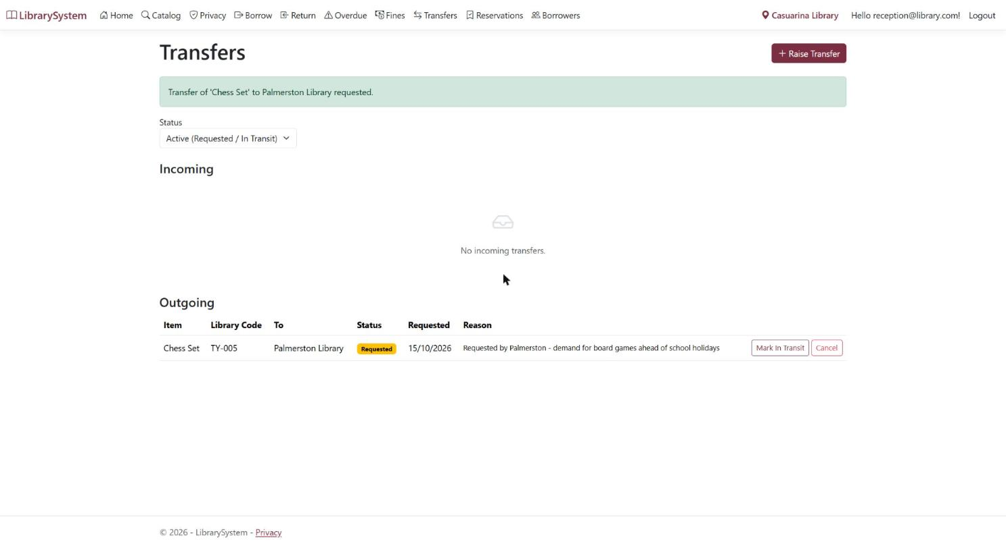
Figure 8 — a newly raised transfer of Chess Set to Palmerston, status Requested, Mark In Transit available to the source branch only
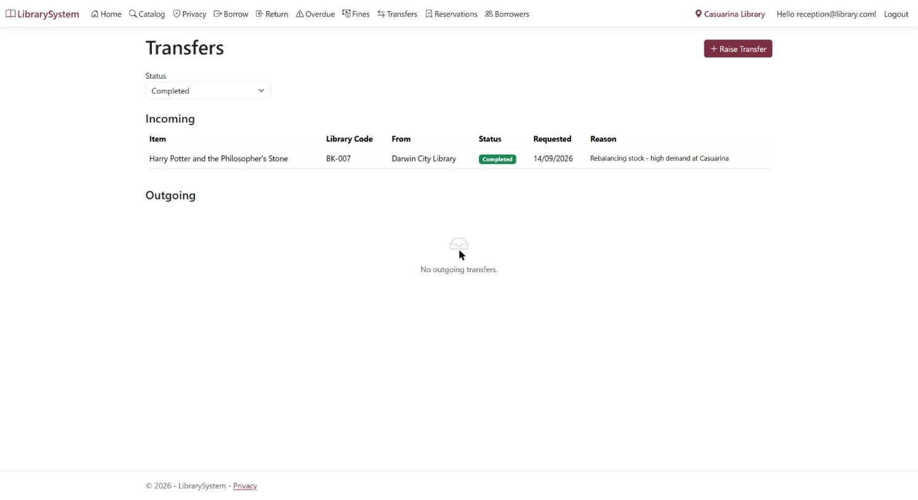
Figure 9 — completed filter showing the historical Harry Potter transfer from Darwin City
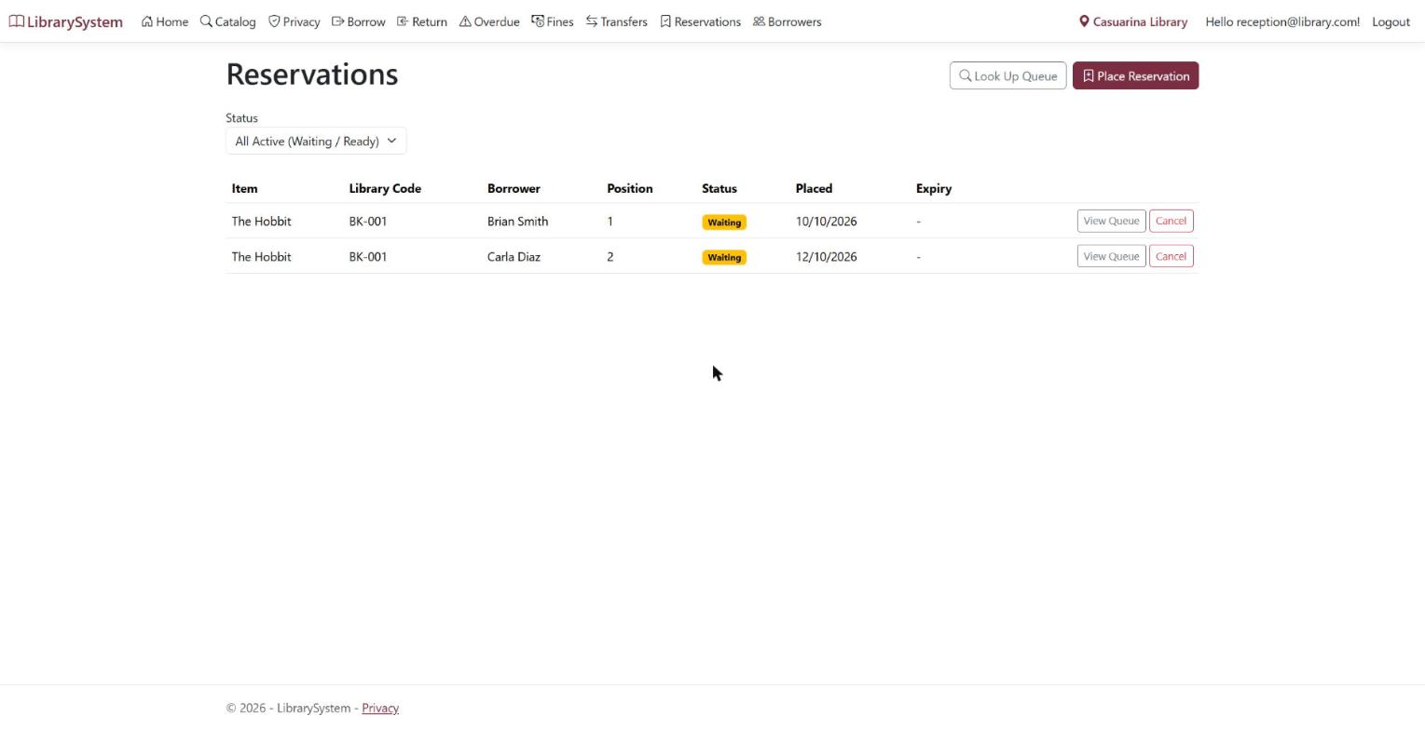
Figure 10 — the Hobbit's two-person queue with positions and placement dates
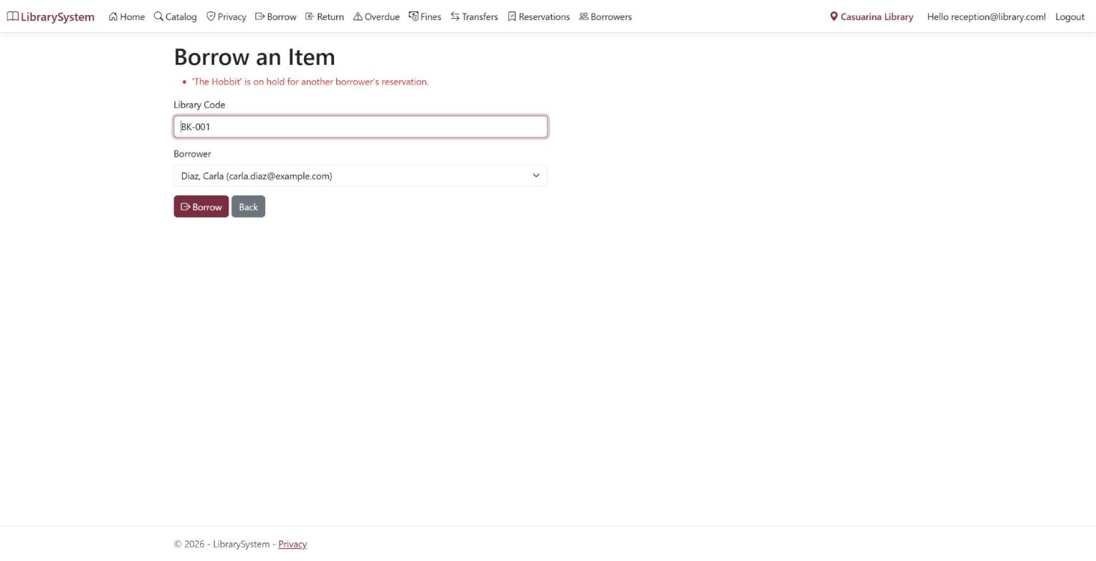
Figure 11 — a borrow refused: "on hold for another borrower's reservation", without naming who
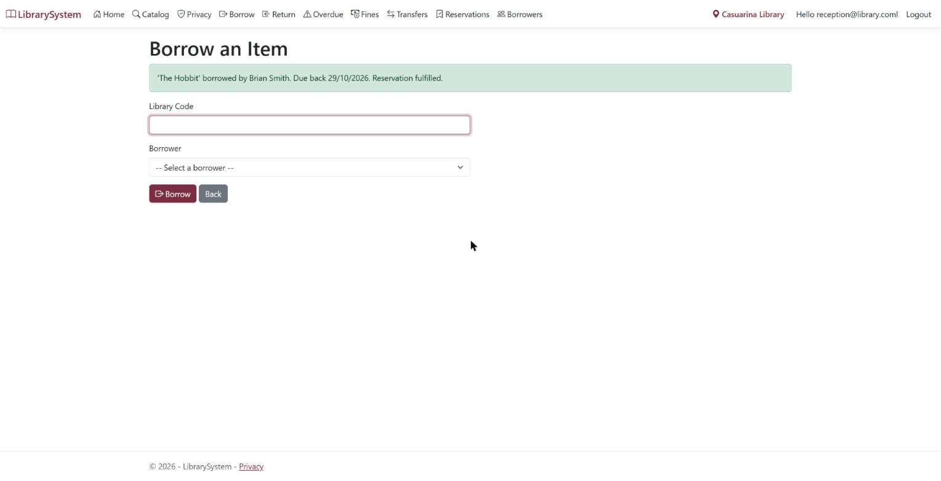
Figure 12 — the same item borrowed by the correct holder: "Reservation fulfilled"
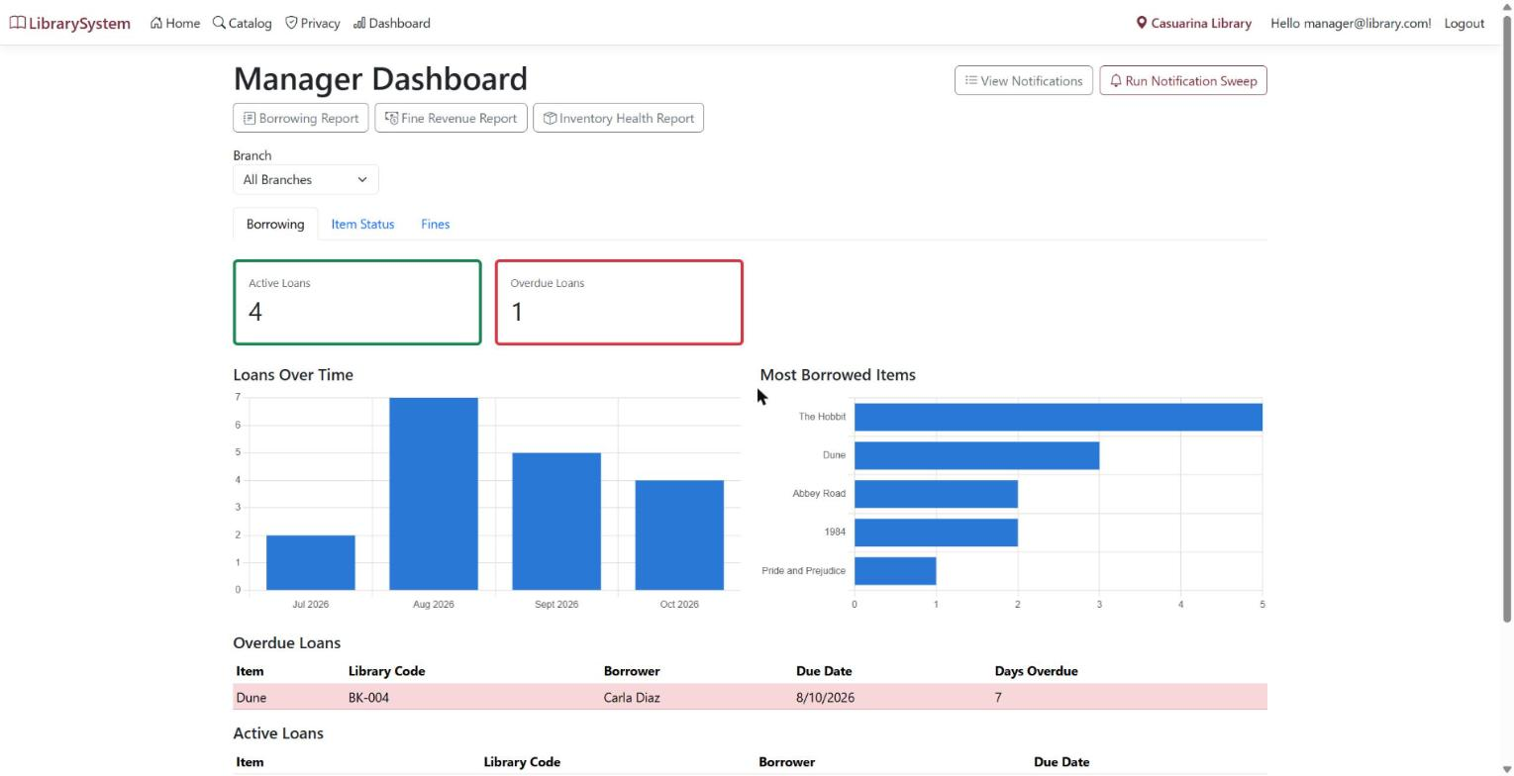
Figure 13 — borrowing tab: loan counts, loans over time, most borrowed, overdue table
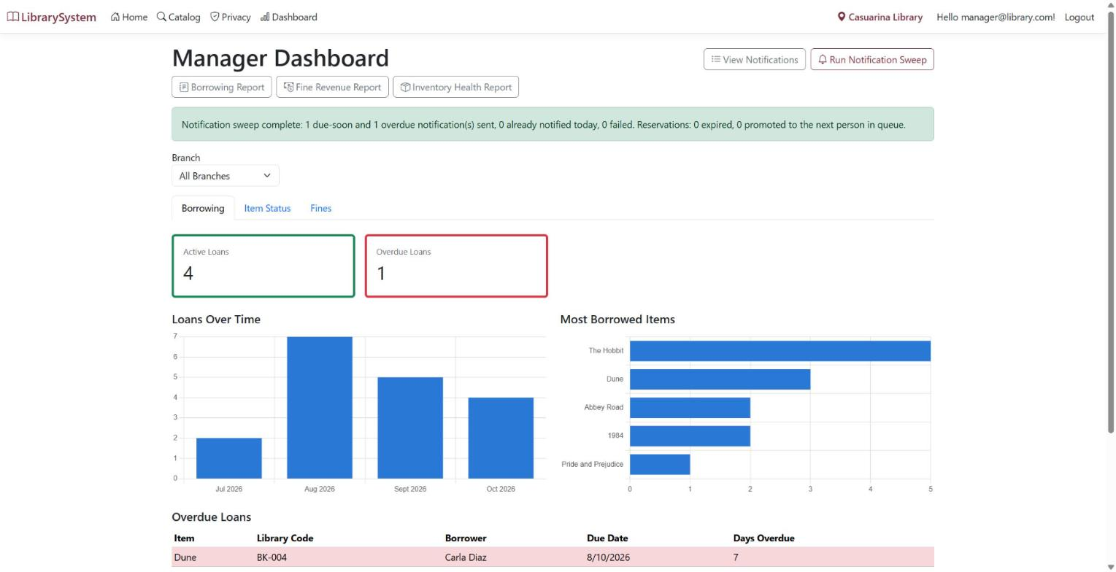
Figure 14 — sweep result: 1 due-soon and 1 overdue sent, 0 already notified, 0 failed
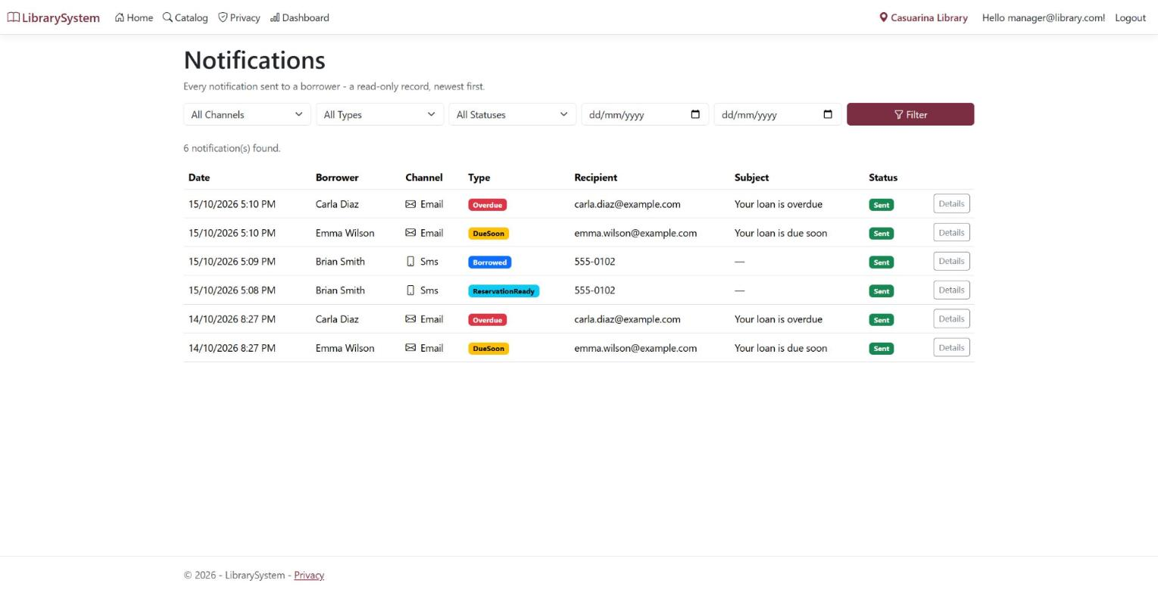
Figure 15 — six notifications across Email and SMS, with correct Darwin local timestamps
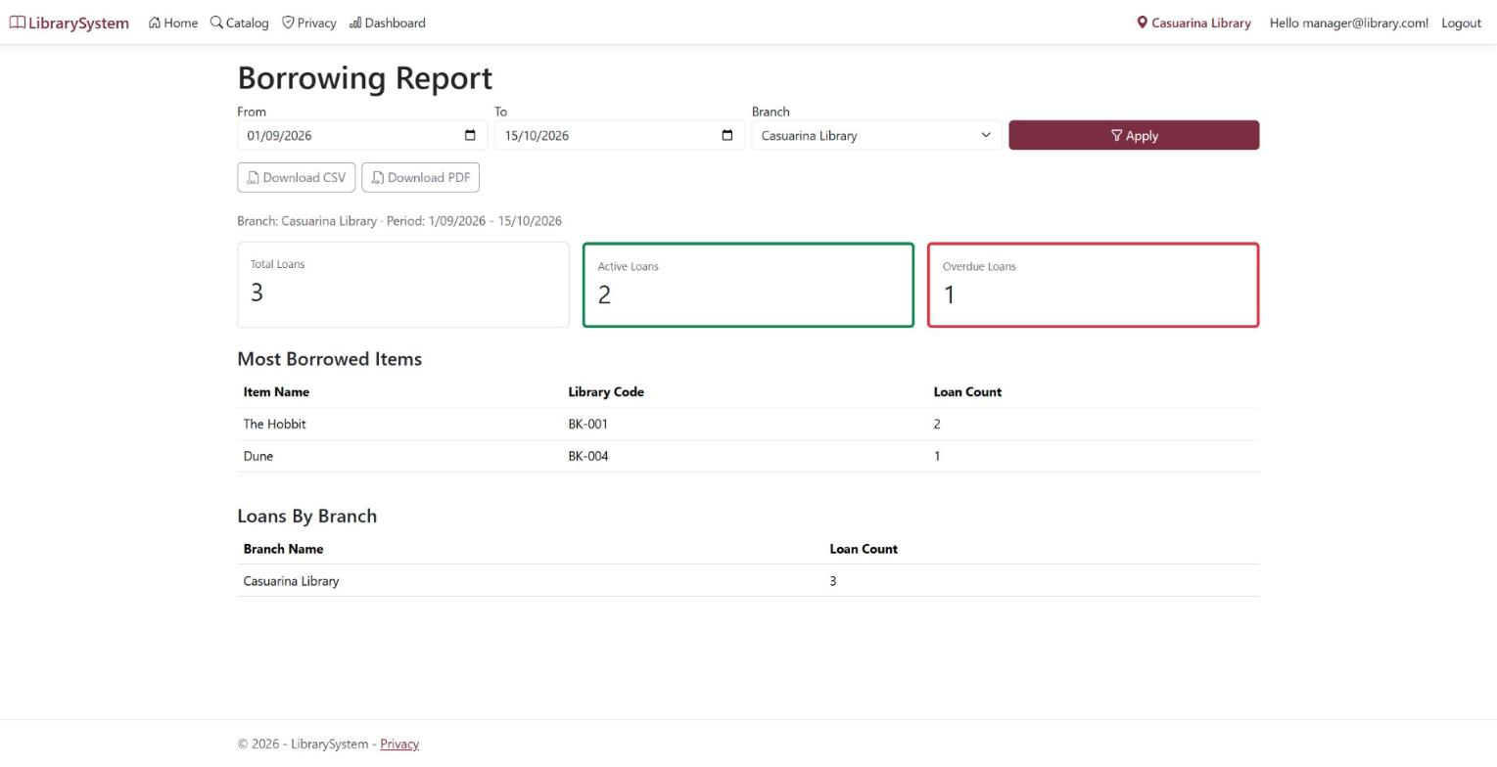
Figure 16 — borrowing report with a custom date range and branch filter applied, CSV and PDF buttons visible
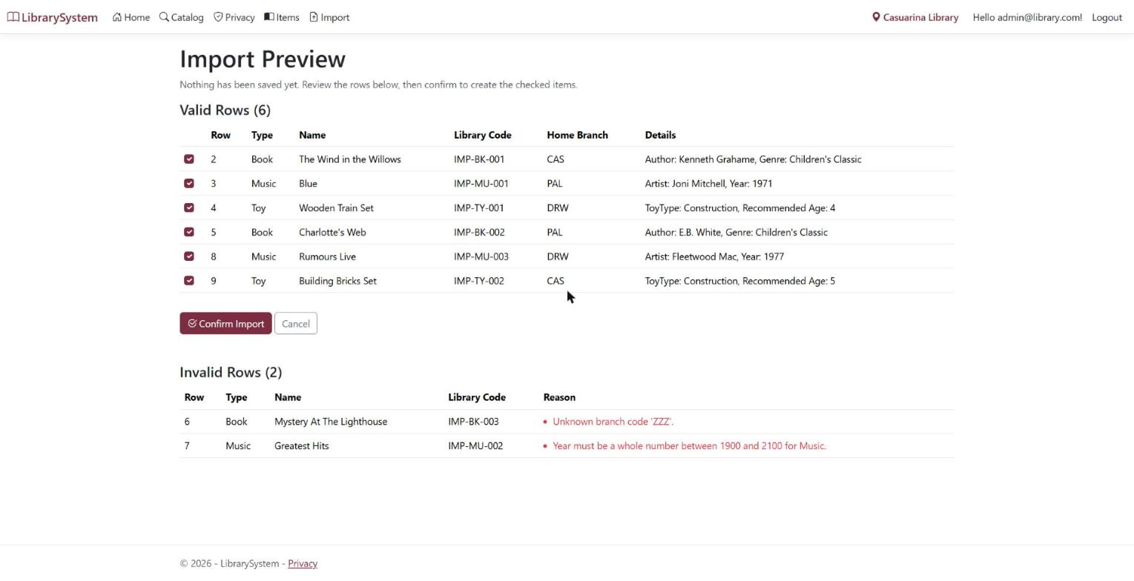
Figure 17 — import preview: 6 valid rows ready to confirm, 2 invalid with specific reasons
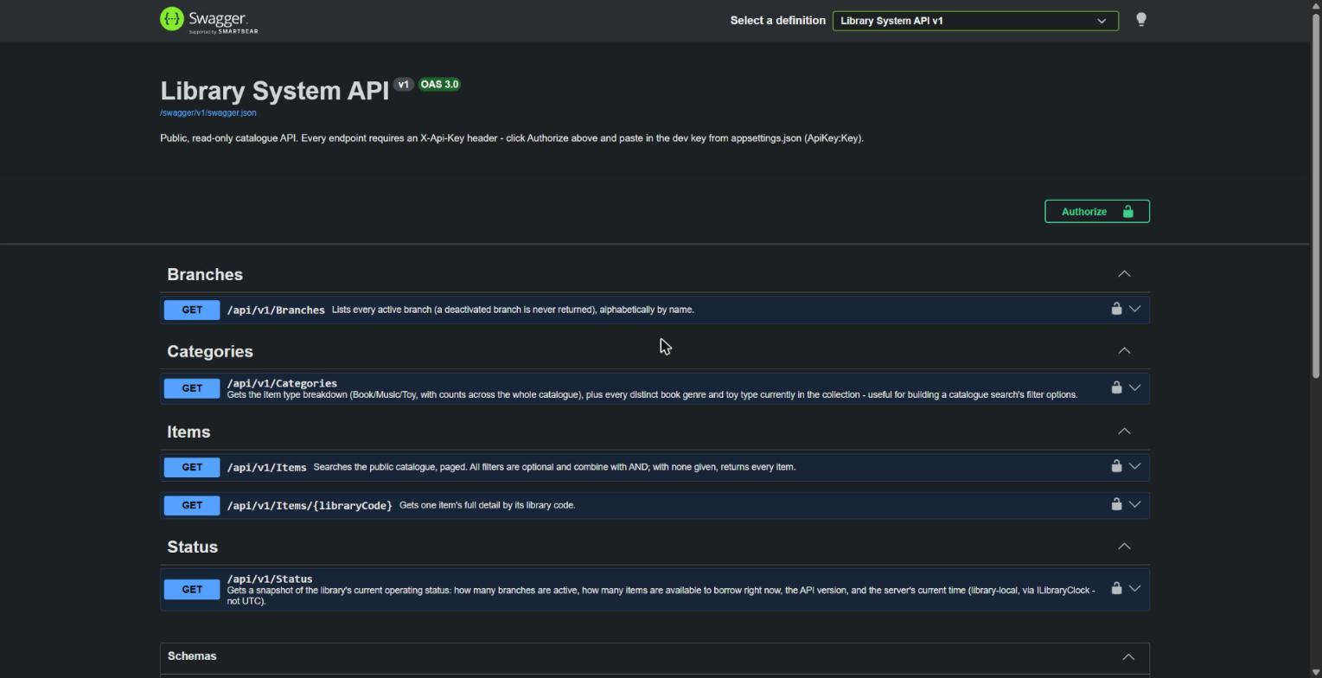
Figure 18 — Swagger listing the five read-only endpoints with the Authorize control
On figures 11 and 12. These two were captured in sequence and show the reservation system's central rule working. The item had just been returned, which promoted the first person in the queue to Ready. The second person in that same queue is then correctly refused, and the person it is held for succeeds. The refusal does not name who the hold is for, which is deliberate: reception does not need to know, and the patron at the desk should not be told.
Database state. Capturing figures 7, 8, 11 and 12 changed data: Dune now has an active reservation for Brian Smith, a transfer of Chess Set to Palmerston sits as Requested, and The Hobbit is on loan to Brian Smith with Carla Diaz remaining in its queue. Deleting the database and re-running restores the original seeded state.

